BARANGAY PASONG BUAYA II E-SERVICES WEBSITE WITH
GIS-BASED DISASTER AND ISSUE MAPPING

Capstone Project
Submitted to the Faculty of the
Department of Computer Studies
Cavite State University – Imus City
Imus City, Cavite

In partial fulfillment
of the requirements for the degree
Bachelor of Science in Information Technology

JAYZEL B. CANTOR
ANGELO J. ODIVILAS
CHRISTIAN MARK D. SANTOS
November 2026
BIOGRAPHICAL DATA

ACKNOWLEDGMENT

ABSTRACT

TABLE OF CONTENTS
Page
BIOGRAPHICAL DATA ii
ACKNOWLEDGMENT iii
ABSTRACT iv
LIST OF TABLES vii
LIST OF FIGURES viii
LIST OF APPENDIX TABLES ix
LIST OF APPENDIX FIGURES x
LIST OF APPENDICES xi
INTRODUCTION 1
Project Context 5
Objectives of the Study 7
Purpose and Description 9
Time and Place of the Study 18
Scope and Limitation of the Study 19
Conceptual Framework 24
Definition of Terms 27
REVIEW OF RELATED LITERATURE 32
RELATED LITERATURE AND STUDIES 32
Local Review of Related Literature 32
Foreign Review of Related Literature 42
Local Review of Related Studies 44
Foreign Review of Related Studies 59
SYSTEM TECHNICAL BACKGROUND 69
SYNTHESIS 71
METHODOLOGY 74
DESIGN OF SOFTWARE, SYSTEMS PRODUCT AND/OR PROCESSES 74
Development Model 74
Data Gathering 75
Requirement Analysis 77
Requirements Documentation 83
System Design 83
SYSTEM DEVELOPMENT 89
SYSTEM TESTING 89
SYSTEM EVALUATION 90
IMPLEMENTATION PLAN 93
REFERENCES 95
APPENDICES 100

LIST OF TABLES

Table |  | Page
1 | Development cost of the project | 80
2 | Yearly operating cost of the website | 81
3 | Gantt chart of the project activities, May to November 2026 | 82
4 | Distribution of respondents | 91
5 | Descriptive interpretation of the mean | 92
6 | Implementation plan for the possible deployment of PB2Link | 93

LIST OF FIGURES

Figure |  | Page
1 | Conceptual framework of the study | 25
2 | Fishbone diagram of the problems in the current barangay services | 79
3 | Use case diagram of PB2Link | 85
4 | Entity relationship diagram of PB2Link | 86
5 | System architecture of PB2Link | 87
6 | Process flow of PB2Link | 88

LIST OF APPENDIX TABLES
Appendix Table |  | Page
1 | Functionality (Part I, all respondents) | 102
2 | Reliability (Part II, all respondents) | 103
3 | Usability (Part III, all respondents) | 103
4 | Efficiency (Part IV, all respondents) | 103
5 | Maintainability (Part V, IT experts only) | 104
6 | Portability (Part VI, IT experts only) | 104
7 | User acceptance testing results | 105
8 | Barangay staff who took part in the testing | 106
9 | Registration and verification test cases | 114
10 | Sign-in and profile test cases | 115
11 | Document and service request and payment test cases | 115
12 | Amenity booking and incident report test cases | 116
13 | Community Issue Map test cases | 117
14 | Disaster risk and notification test cases | 118
15 | Administration and security test cases | 119
16 | Compatibility and accessibility test cases | 119

LIST OF APPENDIX FIGURES

LIST OF APPENDICES
Appendix |  | Page
1 | Relevant source code | 101
2 | Evaluation tool or test documents | 102
3 | Sample input/output/reports | 110
4 | User’s guide | 111
5 | Process/data/information flow | 112
6 | Screen layouts | 113
7 | Test results | 114
8 | Sample generated outputs | 121
9 | Photo documentation | 122
10 | Curriculum vitae | 123
11 | Request for title defense | 124
12 | Title approval sheet | 125
13 | Request for adviser and technical critic | 126
14 | Program of work (Gantt chart) | 127
15 | Budgetary requirements | 128
16 | Request for proposal defense | 129
17 | Proposal defense evaluation | 130
18 | Outline approval sheet | 131
19 | Routing slip before ERB | 132
20 | Certificate of approval (Ethics Review Board) | 133
21 | Request for final defense | 134
22 | Final defense evaluation | 135
23 | Certificate of completion | 136
24 | Routing slip | 137
25 | Certification from the English critic | 138

BARANGAY PASONG BUAYA II E-SERVICES WEBSITE WITH
GIS-BASED DISASTER AND ISSUE MAPPING

Jayzel B. Cantor
Angelo J. Odivilas
Christian Mark D. Santos

An undergraduate capstone project manuscript submitted to the faculty of the Department of Computer Studies, Cavite State University, Imus Campus, Imus City, Cavite in partial fulfillment of the requirements for the degree of Bachelor of Science in Information Technology. Contribution No. ________. Prepared under the supervision of ____________________.

INTRODUCTION

As society becomes increasingly digitized, the government’s adaptation to technological advancements has become a necessity more than a choice. Hence, the adoption of digital platforms in the Philippines for the delivery of government services has been rapidly expanding. It serves as a response to the growing needs of citizens as the country continues to develop. Today many government agencies have successfully merged online services, such as the eGov PH Super App (Presidential Communications Office, 2025a), Civil Registration through the Philippine Statistics Authority (PSA) Serbilis, PhilHealth Online Services, National Bureau of Investigation (NBI) Clearance Online, and the Bureau of Internal Revenue’s ORUS (Online Registration and Update System), among others. The main aim of these platforms is to make government processes faster, more efficient, and more accessible, reducing or even eliminating the need for physical visits to government offices.
Barangay, as the Philippines’ smallest administrative unit, is the first point of contact for national service delivery, yet it continues to struggle with adapting to modern systems. Despite its important role, it remains severely strained by the daily demands of resident record-keeping, maintaining local peace and order, and continuously issuing essential community documents such as clearances, certifications, and permits. Barangay Pasong Buaya II in Imus, Cavite, led by Hon. Barangay Chairman Carlito C. Tagle, is home to 28,916 residents based on the 2024 Census of Population (Philippine Statistics Authority [PSA], 2025), and one of the oldest towns in the Philippines. However, it has long relied on slow, manual, and paper-based processes to carry out these key functions. This setup has held back both the barangay and the wider government effort, because it creates ongoing problems in the accuracy, reliability, and speed of the data being collected.
Under the current setup, finding an old record is often a slow search through physical files, and copying details by hand from one form to another opens the door to mistakes and mismatched information. Residents are also required to be present for almost every step of a transaction, which adds long waiting times and repeated trips for a single request. On top of this, the lack of a central system makes it difficult for the staff to produce timely and correct reports, which weakens the barangay's ability to give higher offices a complete and accurate picture of its transactions and its community.
The daily work of the barangay has a direct effect on how national policy is carried out and on how citizens experience public service. With the national push toward e-governance now in full motion (E-Governance Act, 2025), local units like Barangay Pasong Buaya II have become important parts of the country's move toward a fully digital public service. In response, this study proposes a website built to modernize the core administrative work of the barangay. The website, named PB2Link, automates document requests, builds a centralized Resident Information System that uses Optical Character Recognition (OCR) to help verify residents, supports interactive community issue mapping, and equips the barangay with disaster risk monitoring based on a Geographic Information System (GIS).
The website is designed as a centralized Resident Information System. It serves as the single source of truth for the barangay, moving beyond static records into dynamic profiles. Through self-registration, residents provide their personal, address, and contact details and upload a valid identification card (ID). To keep records accurate, the website scans the ID using OCR through Google Cloud Vision and fills in the form from what it reads. It also checks a Philippine Identification System (PhilSys) card against the resident’s name, checks that the verification selfie shows the resident holding the same ID, and confirms the email address and mobile number through one-time codes. A residency rule asks for a proof of address or a barangay endorsement when the ID does not show a Pasong Buaya II address or when the resident has lived in the barangay for less than six months. Each registration receives a unique control number, possible duplicate accounts are flagged, and an account that passes every check can be approved automatically, while the rest are reviewed by barangay staff.
The website is designed to reduce the long-standing inefficiencies caused by manual workflows by giving residents an accessible place online where they can submit requests, verify requirements, and track the progress of their transactions without the need for repeated physical visits. This is achieved through a Verified-First Automated Document Workflow. Upon requesting documents such as the Barangay Clearance, the Certificate of Residency, or the Barangay ID, most of the form is filled automatically using the resident’s verified profile, and the valid ID submitted during registration is reused instead of being uploaded again. Requirements are checked online before release, so a document is not marked ready for pick-up until its payment and any needed proof of residency have been verified by staff. When a registration itself has problems, staff can ask the resident to fix specific items online through a restricted account before sending it back for review.
Through this website, residents can request various Barangay documents and dynamic custom services created by the administration. They can fill out their information online, securely upload e-wallet payment receipts, and receive notifications about the status of their requests. The website also provides the barangay admin an organized, secure, and responsive administrative interface that enables faster verification, record retrieval, and systematic data management of registered residents.
Simultaneously, this website also provides other significant services to the residents such as a GIS-Based Disaster Risk module and a Community Issue Map. The Community Issue Map allows residents to pin neighborhood problems, such as road damage or flooding, directly onto a map that only accepts pins inside the official barangay boundary. Reports from other residents act as votes that change the color of each flag, while a 30-meter duplicate check keeps the map from being cluttered with repeated pins. For public safety, the disaster risk module reads live hazard information from the Philippine Atmospheric, Geophysical and Astronomical Services Administration (PAGASA), the Philippine Institute of Volcanology and Seismology (PHIVOLCS), and the Global Disaster Alert and Coordination System (GDACS), shows a seven-day weather forecast, and maps the evacuation centers together with their capacity and the number of families staying in them. Its map also shows flood-prone areas from Project NOAH (Nationwide Operational Assessment of Hazards) and a rain radar, and it can point a resident to the nearest open evacuation center. During emergencies, staff can send advisories to residents through Short Message Service (SMS) text messages and through alerts on their phones.
To keep residents informed, the website uses a dual-channel notification feature that sends both email and SMS through PhilSMS. One-time verification codes are sent by email and SMS during registration, profile edits, and password resets. Notices about document requests are always sent through both channels, while other notices follow the channel each resident prefers, and an email is sent whenever a text message cannot go through. Finally, the administrative side is protected by hierarchical access. The Super Admin manages admin accounts, system settings, and the audit log, and decides which tabs each standard admin can open, while standard admins handle the daily work such as resident approvals, document processing, and community reports.
Beyond these core services, the website helps residents prepare for disasters. A preparedness page shows the flood level of each street based on the Project NOAH flood map, together with emergency hotlines, guides on what to do before, during, and after a hazard, and checklists for a go-bag and a family plan. A light emergency page keeps the latest advisory, hotlines, and evacuation centers available on a resident’s phone even without an internet connection. The resident side of the website also follows the Web Content Accessibility Guidelines (WCAG) 2.2, and it includes an accessibility menu where residents can enlarge the text, raise the contrast, reduce motion, and make the text easier to read.
PB2Link aims to close the gap between the e-government services of national agencies and the way services are still delivered at the barangay level. It moves routine work online and adds automatic checks and notices, so that requests are handled faster, records are more accurate, and staff spend less time on repeated paperwork. For Barangay Pasong Buaya II, the website is meant to be a first step toward a barangay office that is easier to reach and easier to hold accountable.

Project Context
PB2Link is conceptualized and developed in response to the inefficiencies and shortcomings of the barangay’s present manual handling of essential resident services. The manual system has historically operated in the barangay for many years, but now given the continuing growth of the community and the current increased possibilities of addressing multiple needs in a more technological way, the manual system becomes immediately inefficient and unsustainable. The foundation for this endeavor was built upon initial data gathering, which included a face-to-face interview with the Barangay Secretary of Pasong Buaya II, Digna E. Cabrera. As a result of this consultative process, the researchers have come to understand that the current operational design has several apparent shortcomings that negatively affect service delivery, record management, and the overall citizen experience.
Barangay Pasong Buaya II located in Imus, Cavite with a population of 28,916 in the 2024 census is highly dependent on paper-based and manual interventions that handle the resident records and issue of essential documents. These operations produce inaccurate and unreliable data as there are transcription and authentication errors within the process that result in unverified and incomplete records. The lack of a records and data management system makes it difficult to properly organize, store, and maintain the resident data for long-term use, which also affects the retrieval of past records that can take a long time and can often be misplaced.
With the current system, residents are routinely subjected to long waiting times, the repetitive and inefficient task of filling out forms multiple times during the course of a single request, and difficulty in tracking the real-time status of their document transaction. Meanwhile, the efficiency of the barangay staff is affected by a demanding and repetitive workload, as they have to handle many manual, operational tasks including transcription, filing, and retrieval which detracts them to focus on higher priority duties. The lack of automation also creates an inability to obtain timely and accurate reports which affects the ability of the barangay to provide higher administrative offices with complete transaction histories. Combined, these inefficiencies compromise transparency, accountability, and service efficiency, hindering both local and national governance.
PB2Link is designed to solve these problems by moving the barangay’s main tasks into one website. It addresses data unreliability by establishing Strategic Resident Profiling verified by OCR ID scanning and PhilSys checks, which acts as the single source of truth for the community. Each resident must pass a verification process, which includes a selfie check and, when needed, a proof of residency, so that the records the website keeps are accurate. The problem of long waiting times and repetitive form filling is resolved through a Verified-First Automated Document Workflow. This module pre-fills document requests with saved profile data and accepts e-wallet payment receipts that staff verify, so that the whole transaction can begin online.
To support community safety and engagement, the website integrates a GIS-based Community Issue Map for reporting local concerns through pins on a map, and a Disaster Risk module for weather and hazard monitoring, evacuation center mapping, and emergency alerts by SMS and on residents’ devices. A preparedness page and an offline emergency page add guidance that residents can use before and during a disaster. Through these integrated modules, the website seeks to create a more efficient, transparent, and citizen-friendly service environment for Barangay Pasong Buaya II.

Objectives of the Study
The general objective of this study was to design and develop the Barangay Pasong Buaya II E-Services Website with GIS-Based Disaster and Issue Mapping, named PB2Link.
Specifically, the study aimed to:
- design a website with the following features:
  - a resident registration and profiling module with OCR-assisted ID scanning, PhilSys card matching, a verification selfie check, and residency rules that keep resident records authentic;
  - a verified-first e-services module for the Barangay Clearance, Certificate of Residency, Certificate of Indigency, Business Clearance, and Barangay ID, together with volunteer registration, incident reports, custom services built by staff, and amenity bookings with conflict checking;
  - a fee and payment tracking module that accepts receipts of e-wallet payments made through the barangay’s Quick Response (QR) code and payment at the barangay hall, lets staff verify each payment and record its Official Receipt (O.R.) number, and applies fee exemptions for first-time jobseekers, indigent residents, senior citizens, and persons with disabilities (PWD);
  - a dual-channel notification feature using PhilSMS and email that sends one-time verification codes, request status updates, and emergency advisories, with an email sent whenever a text message cannot go through;
  - a GIS-based disaster risk module that shows a seven-day weather forecast, maps evacuation centers and their capacity, displays flood-prone areas and a rain radar, finds the nearest open evacuation center, and reads live hazard information from PAGASA, GDACS, and PHIVOLCS so that staff can post advisories in English and Filipino;
  - disaster preparedness tools, including street flood levels, emergency hotlines, before, during, and after guides, household checklists, an officials’ task checklist, a list of senior and PWD residents for evacuation planning, and an emergency page that opens even without an internet connection once it has been opened on the phone;
  - a Community Issue Map limited to the barangay boundary that uses report counts as votes to color-code flags, checks for duplicate pins within 30 meters, and gives staff a timeline, a management dashboard, and a heatmap of where reports are concentrated;
  - an information and waste management module covering collection schedules by zone, collection route maps, segregation guides, announcements targeted to specific sectors, and an editable About page and council list;
  - an administration module with Super Admin and Standard Admin roles, a dashboard, resident records that can be searched and filtered, reports exported as CSV files, an audit log, and tab access permissions set by position or for each admin; and
  - an accessibility menu for text size, contrast, motion, and reading spacing, with the resident side of the website following WCAG 2.2 Level AA;
- develop the website using React 19 and Vite for the front end, PHP for the back end, and MySQL for the database, built and tested locally with XAMPP on a laptop or desktop that has at least an Intel Core i5 processor, 8 gigabytes (GB) of random access memory (RAM), and 256 GB of storage, and hosted online through Hostinger shared hosting at pb2link.com;
- test the website through unit, integration, system, and user acceptance testing to make sure that each module works as intended;
- evaluate the website using the International Organization for Standardization and International Electrotechnical Commission (ISO/IEC) 9126 software quality model in terms of functionality, reliability, usability, efficiency, maintainability, and portability, as rated by barangay staff, residents, and IT experts; and
- prepare an implementation plan for the possible deployment of the website in Barangay Pasong Buaya II.

Purpose and Description
The purpose of this project is to change how administrative work is done at Barangay Pasong Buaya II by moving from a manual, paper-based routine to a modern website. The new website automates key tasks such as resident profiling, document processing, facility booking, and reporting, while adding tools that improve community safety and communication. The result is meant to be a barangay service that is faster, clearer, and easier for residents to reach online via pb2link.com. PB2Link is organized into the following main areas:
Registration and resident verification. A resident creates an account through a four-step form: Valid ID, Profile, Address and Contact, and Review. In the first step, the resident chooses the type of valid ID and uploads or takes photos of its front and back. The website sends the front of the ID to Google Cloud Vision, which reads its text through OCR, and fills in the name, birth date, and ID number from what it reads. The resident checks these details and corrects them before continuing. If the photo is blurry, or if the scanning service is unavailable or has reached its monthly limit, the resident types the details instead. The resident then uploads a selfie holding the same ID. The website checks that the selfie is not the same file as the ID photo, that it shows a face together with the smaller photo printed on the ID, and that the resident’s name can be read on the card. If the check fails, the resident is asked to retake the photo, and after two failed tries the resident may continue while staff review the selfie. In the Profile step, the resident enters personal details such as civil status, sector, and residency status. A resident who has a PhilSys card may add its number by uploading photos of the card, and the website checks that the number and the name printed on it match the form. Applicants under 18 years old must add a parent’s or guardian’s ID showing the signature and, when their surnames differ, one consent document: a letter signed by the guardian, a PSA birth certificate naming the parent, or a guardianship document. In the Address and Contact step, the resident chooses the subdivision and street from lists of the barangay’s streets, or types a name that is not on the list, and enters the month they moved into the barangay. The website also reads the address on the scanned ID. If the resident has lived in the barangay for less than six months, or if the ID does not show a Pasong Buaya II address, the resident must upload a proof of address or a barangay endorsement. When the resident submits the form, the website first confirms the email address with a six-digit code and then the mobile number with a code sent by SMS, and the resident chooses whether notices should arrive by email, SMS, or both.
Account review. Each registration receives a unique control number. The website approves an account automatically only when every check passes: the name on the ID matches the scan of that same photo, the selfie check passes, the PhilSys card matches or none was given, the applicant is at least 18 years old, no likely duplicate exists with the same name and birth date or the same PhilSys number, the residency rule needs no proof, and the Super Admin has turned automatic approval on. Any other account stays Pending, and the website lists the reasons for staff. Staff open each record, compare the scanned details with what the resident entered, view the ID, selfie, and proof images, and then approve the account, archive it with a reason, or ask the resident to act. When staff ask the resident to act, they either choose the items to fix online or ask the resident to visit the barangay hall. A resident asked to fix items online signs in to a restricted account that opens only Edit Profile, makes the requested changes, and sends the account back for review. After three such returns, only a visit to the hall is offered. Sector claims such as PWD, solo parent, 4Ps, or indigent status always go to staff with their supporting document, even on an account approved automatically. Records are never deleted. Staff archive them with a reason under a Create, Read, Update, and Archive (CRUA) policy, which keeps the record for audit while removing the resident’s access.
Resident profile. After approval, residents manage their information in Edit Profile. Changes to the name, sex, birth date, or PhilSys number need a one-time code and then staff approval. A name change also needs a supporting document, and a PhilSys number needs photos of the card, which is scanned so that a matching card can be applied right after the code without waiting for staff. Changes to the address or the move-in month need a code, a proof of the new address, and staff approval, and the old address stays until staff approve. Changes to the residency status, emergency contact, email address, mobile number, and password need only a code. The resident chooses whether each code arrives by email or SMS. A new email address receives its code by email, and a new mobile number receives its code by SMS. Each code lasts 10 minutes and is locked after five wrong tries. Staff cannot change details that need proof. Instead, they send the resident a change request, which appears at the top of Edit Profile until the resident makes the change. Residents also choose here how they receive notices and whether advisories reach them in English or Filipino.
E-services module. Residents request the Barangay Clearance, Certificate of Residency, Certificate of Indigency, Business Clearance, and Barangay ID, and they also register as volunteers. Each request starts by choosing whether it is for the resident or for someone else. A request for oneself is filled in from the verified profile and reuses the valid ID from registration, so no new ID is uploaded. A request for someone else needs that person’s details, their valid ID, and an authorization letter. Each form then asks for its own details, such as the purpose, the business information for a Business Clearance, proof of low income for a Certificate of Indigency, or the photo and signature for a Barangay ID. A resident who has lived in the barangay for less than six months must have a proof of residency on file, and a Certificate of Residency for oneself reuses the proof or the ID address already on file. Staff may add extra questions to any form, which appear under Additional Questions. If the resident leaves the page or refreshes it, the website keeps what was typed for up to 12 hours. The last step shows the fee and the payment options. On submission, the request receives a tracking code, and the resident is notified by both email and SMS. Staff then move the request through Pending, Processing, Ready for Pick Up, and Claimed, or decline it with a reason, and the resident is notified at every change. A document cannot be marked Ready for Pick Up until its payment is verified and any needed proof of residency has been checked. Staff print the certificates and the Barangay ID card from the website, with the council members and signatories taken from the barangay’s official list. The resident then claims the document at the hall.
Custom services. Staff can create new services through a form builder without changing the website’s code. The form always asks for the applicant’s identity, address, valid ID, and fee on its own, and staff add only the service’s questions, which can be short or long answers, numbers, dates, times, dropdowns, multiple choice, checkboxes, or file uploads, each with a hint and a required setting. A new service starts closed, staff can preview it as a resident before opening it, and a service that already has requests can be closed but not deleted. Staff can also rename the five built-in documents and the other built-in services, reorder them on the Services page, or close them with a message, and the website refuses new requests for a closed service. When a custom service request is declined, the resident can send it again from Track Request with the earlier answers already filled in.
Amenity booking. Residents book the barangay’s venues, vehicles, and equipment. A venue or vehicle is booked for a start and end time within its opening hours and cannot overlap another pending or approved booking, and a vehicle booking also needs a destination. Equipment is booked by quantity, which cannot exceed what is still available that day. The ambulance cannot be booked online, so its page shows its hotline number instead. Each resident can hold at most two active bookings. Staff approve, decline, complete, or cancel each booking on a calendar, and approving a booking automatically declines the pending bookings it overlaps. A resident can cancel their own pending booking from Track Request.
Incident reports. Residents report incidents with a description and an optional photo. Staff move each report through Pending, Processing, and Resolved or Closed, and the resident is notified of each change through their preferred channel.
Track Request. Residents follow all their requests, bookings, and incident reports on the Track Request page, or search by tracking code. Each request shows its status timeline, the details and files submitted, the payment status, and when an update can be expected. Documents and bookings are processed within the day during office hours, from Monday to Friday, 8 AM to 5 PM, and incident reports and profile updates within 24 hours.
Fees and payments. Staff set the fee for each document and custom service based on the barangay’s revenue ordinance, and the website copies the fee onto each request when it is submitted. At the last step of a request, the resident chooses one of three options. To pay online, the resident scans the barangay’s official QR code in their e-wallet app, pays the exact amount, enters the reference number, amount, and date, and attaches the receipt. To pay at the hall, the resident submits the request and pays when claiming it. To claim an exemption, the resident ticks the exemption that applies. The website refuses a reference number or receipt image already used on another request and flags a wrong amount or a payment date more than 30 days old. Staff with payment access then match the reference number against the barangay’s e-wallet history, record the Official Receipt (O.R.) number issued by the treasurer, and mark the payment Paid, or reject it with a reason so that the resident can upload a new receipt from Track Request. Fees are waived for residents whose Indigent, Senior Citizen, or PWD status is verified on their record, and for first-time jobseekers under Republic Act (RA) No. 11261, which can be used once after staff confirm the oath. Every payment change is recorded and sent to the resident by email and SMS, and staff can download a collections report for reconciliation with the treasurer’s records.
Notifications. The website sends notices by email and by SMS through PhilSMS. Codes for registration, profile changes, and password resets go by email or SMS. Notices about document requests are always sent by both, while notices about bookings, incident reports, profile decisions, and account changes follow each resident’s preferred channel. When a text message cannot be sent, because the number is invalid, the provider fails, or the monthly limit is reached, the website sends an email instead. Each text is kept within one SMS of 160 characters, and the website counts every text against the barangay’s monthly limit. Residents and admins can also reset a forgotten password through a code sent by SMS.
GIS-based disaster risk module. The disaster risk page shows a map of the barangay built with Leaflet over OpenStreetMap, framed by the official barangay boundary, with the area outside shaded. Staff place each evacuation center on the map and record its capacity, the number of families staying in it, its status, and its contact numbers. Residents can turn on map layers for evacuation centers, flood-prone areas from the Project NOAH 100-year flood map, and a rain radar from RainViewer showing the past two hours. With “Find my nearest evacuation center,” the website uses the phone’s location, or a spot the resident taps on the map, measures the straight-line distance to each center, and shows the closest one that is not full or closed, with the distance, an estimated walking time, the space left, its phone numbers, and a link to walking directions in Google Maps. It also reads the Project NOAH map at that spot and tells the resident if it lies in a low, medium, or high flood hazard area. The location stays on the resident’s device. The page also shows a seven-day weather forecast from Open-Meteo, and during an active advisory it shows residents’ open flooding and road damage reports from the Community Issue Map.
Live hazard feeds and advisories. The website refreshes five outside sources whenever someone opens the Home page or a Disaster Risk page and a source’s saved copy is older than 10 to 30 minutes: the PAGASA severe weather bulletin for wind signals over Cavite, GDACS for tropical cyclones near the Philippines, PHIVOLCS for earthquakes, with USGS as a backup, and the Open-Meteo rainfall forecast. When a reading is serious, such as a wind signal over Cavite, a strong earthquake nearby, or heavy rain in the forecast, the website records it once. Depending on the Super Admin’s setting, it only shows the readings, prepares a draft advisory for staff to review and publish, or publishes the advisory itself, while rain forecasts always stay drafts. Staff write advisories from ready templates in English and Filipino, and the website refuses an advisory with an unfilled blank such as the affected areas. When an advisory goes live or is raised to a higher level, the website sends an alert to devices that have turned alerts on and, if the Super Admin chose automatic SMS, texts every active resident with a mobile number once for each level. Otherwise, staff send texts to all residents, to an area, to a sector, or to one number. Staff can also run practice advisories that only staff can see and receive. An active advisory that has not been confirmed for 24 hours is flagged for review, and each advisory shows a checklist of tasks for officials at its alert level.
Preparedness and emergency information. The preparedness page lets anyone look up the flood level of a street, which was worked out from the Project NOAH map along each street’s shape. It also lists emergency hotlines with tap-to-call, guides on what to do before, during, and after a typhoon, flood, earthquake, or fire, and go-bag and family plan checklists whose ticks stay on the resident’s device. A signed-in resident sees their own street’s flood level on the Home page and in Edit Profile. Staff with permission can view a list of senior citizens and PWDs grouped by street, starting with the streets that flood the most, and every view or print of this list is recorded. A light emergency page keeps the active advisory, the hotlines, the evacuation centers, and the guides on the resident’s phone, so it still opens without an internet connection once it has been opened before.
Community Issue Map. Anyone can view the map of reported neighborhood problems, which covers broken streetlights, illegal dumping, road damage, flooding, stray animals, noise, fire hazards, and water problems, while only signed-in residents with an active account can read the comments. To report a problem, a signed-in resident taps the spot on the map or uses the phone’s location, chooses the type, writes a comment, and may add a landmark and a photo. The website refuses a pin outside the barangay boundary, and when an open issue of the same type lies within 30 meters, it suggests adding the report to that issue instead. Each report counts as a vote, and the flag changes color from yellow to orange, red, and purple as reports increase. Each resident can add at most five new pins a day and one report per issue, and can withdraw their own report while the issue is open. Comments are shown without names. Staff see every reporter, a heatmap of where reports are concentrated, and filters, and they update each issue with a public remark that residents see under “Barangay staff.” Staff can also hide a comment or merge duplicate pins. Reporters are emailed when the status changes and, if they chose SMS, receive a text message when the issue is resolved. Closed issues stay on the map behind a toggle for seven days.
Home page and information. The Home page has a search box for services, pages, and tracking codes, a summary of the active advisory, the weather, the coming week’s garbage collection, the most reported issues, and, for a signed-in resident, their requests and their street’s flood level. Residents can rearrange, resize, and hide these tiles. Staff post announcements with a headline and up to six photos, for everyone, for specific sectors, or for specific residents, and can pin up to three at the top. The waste management page shows collection schedules by zone, route maps that staff draw along the streets, and a segregation guide. Staff also edit the About page and the council list, which also supplies the signatories of printed documents.
Administration. Admins sign in to a separate admin side. The dashboard shows the day’s tasks and counts across all modules and refreshes every two minutes. On the Residents page, staff search and filter resident records, open a record with its verification checks, images, requests, and change history, and approve, archive, or restore accounts. Staff can edit only details that need no proof, each edit needs a reason, and the resident is told of every change. Profile Approvals holds the profile changes waiting for a decision, and the Address List lets staff add, rename, or hide streets and review names that residents typed. The Super Admin invites each admin by email and mobile number, and the admin activates the account with a code sent to each and then sets a password. The Super Admin also decides which tabs each standard admin can open, by default, by barangay position, or for one person, and sends password reset links instead of setting passwords. After five incorrect passwords for the same email, sign-in is paused for 15 minutes, and a paused admin account is recorded and the admin is told by email. Every staff action is recorded in an audit log that only the Super Admin can read and export.
Accessibility. The resident side of the website follows WCAG 2.2 at Level AA. It can be used with a keyboard alone, its text and buttons meet the required color contrast, and each map has a list version for residents who cannot use a map. An accessibility menu lets residents enlarge the text, raise the contrast, reduce motion, add reading space, and underline links, and an Accessibility page explains what is supported and where to get help.
PB2Link is expected to benefit the following groups:
Barangay staff. The staff gain a faster and more organized way to handle records and requests. Automation and OCR-assisted verification remove much of the repeated clerical work and manual data entry, which frees them to focus on tasks that need real judgment. With profiles, requests, and interactive maps kept in one place, they can serve residents more quickly and with fewer mistakes.
Residents. Residents can reach barangay services more easily. They register once, then submit requests, upload payments, check status, and receive SMS and email updates without returning to the hall for every step. The Community Issue Map gives them a direct voice in reporting local problems, while the disaster and preparedness tools, the offline emergency page, and the accessibility menu help residents with different needs stay informed and safe.
Local government unit. The barangay gains more accurate and timely data, which supports better planning and resource use. The disaster risk module and live hazard feeds help officials prepare for emergencies, ensuring that evacuation centers and public advisories are managed efficiently and transparently.
Researchers and future academics. The project gives the research team direct experience in building a working government website, including the challenges of data privacy, external application programming interface (API) integration (Vision, SMS, Maps), and user design. It can also serve as a reference for future students studying the digitalization of local public service.

Time and Place of the Study
This study was carried out as part of the capstone requirement of the program. The research, website design, development, and testing took place from May 2026 to November 2026, from the preparation of the outline to the preparation of the manuscript. The study was conducted at Barangay Pasong Buaya II in Imus, Cavite, Philippines. The barangay was chosen because it still relied on manual methods for resident profiling and document requests. Requirements, workflow observations, and validation were done together with barangay staff based on their actual procedures. The researchers tested the website using sample data, and it was not connected to the barangay’s actual records. During the evaluation, residents registered on the live website at pb2link.com with their own valid IDs after giving their consent.

Scope and Limitation of the Study
This study covers the design, development, testing, and evaluation of PB2Link, a website for Barangay Pasong Buaya II in Imus, Cavite, conducted from May 2026 to November 2026. The website aims to automate manual work, reduce time-consuming administrative tasks, and limit human error in the handling of resident data. It serves three kinds of users: residents of the barangay, barangay staff with Super Admin or Standard Admin access, and the public, who can view the announcements, the services list, the disaster risk and preparedness pages, the waste collection schedules, and the Community Issue Map without signing in. The website includes the Registration and Profiling Module, the E-Services Module, the Fees and Payment Module, the GIS-Based Disaster Risk Module, the Community Issue Map, the Information and Waste Management Module, the Notification framework, the Preparedness and Accessibility features, and the Administrative and Technical Governance Module. It was tested on Chrome on Android phones, Safari on iPhones, and Chrome on Windows computers, and it was evaluated by five barangay staff, 30 residents, and five IT experts using the ISO/IEC 9126 software quality model.
Registration and profiling module. This module covers self-registration, resident verification, and the resident’s own profile. It uses the Google Cloud Vision API for OCR ID scanning and the selfie check, which are subject to a monthly scanning cap; when the cap is reached or the service is unavailable, residents type their ID details instead and staff review the account. The selfie check only confirms that the photo shows a face together with the ID. It does not compare faces or test whether the person is live. The PhilSys check only compares the details printed on the card photo with what the resident entered. The website is not connected to the PhilSys database of the PSA, and it cannot detect a forged ID, so staff make the final decision on doubtful accounts. Registration requires a working email address and mobile number, since each is confirmed by a one-time code, and the website has no walk-in registration by staff, so residents without these must ask a family member for help or continue to transact at the barangay hall. Applicants under 18 years old must add a parent’s or guardian’s ID and are always reviewed by staff. The module enforces residency rules based on move-in dates and ID addresses, and staff use a non-destructive archive function (CRUA policy) to flag a resident as inactive while keeping the record for audit. The barangay’s historical population records are not moved into the website.
E-services module. This module manages document requests, volunteer registration, incident reports, custom services, and amenity bookings. Residents request documents online, and the website pre-fills the forms from verified profiles. Each resident can hold at most two active amenity bookings, and the ambulance cannot be booked online; residents call its hotline instead. Staff can print certificates and ID cards from the website, but the website does not apply digital signatures, and the resident must still appear in person to claim the document. Incident reports are reviewed by staff, usually within 24 hours. They do not replace emergency hotlines such as 911, and the website does not dispatch responders.
Fees and payments. Fees apply to the five document requests and to the custom services that staff give a fee. Staff set each fee based on the barangay’s revenue ordinance, and each request keeps the fee in force when it was submitted. The website does not process or collect payments. It has no payment gateway and is not connected to any e-wallet, so residents pay outside the website, either by scanning the barangay’s QR code in their e-wallet app or by paying at the hall. The receipt a resident uploads is only a proof of transfer, not an Official Receipt. Staff match its reference number against the barangay’s e-wallet history by hand, and the treasurer still issues the O.R., whose number staff then record in the website. The website refuses a reference number or O.R. number that was used before and a receipt image already attached to another request, and it flags wrong amounts and payment dates more than 30 days old, but it never confirms a payment by itself. A document is not released until its payment is marked Paid or Waived. Fee exemptions apply only to requests that residents make for themselves. The first-time jobseeker exemption under RA No. 11261 can be used only once and needs the oath to be confirmed by staff, while the Indigent, Senior Citizen, and PWD exemptions need that status to be verified on the resident’s record. Refunds are recorded in the website, but the money is returned outside it. Volunteer registration, incident reports, and amenity bookings have no fee handling in the website, so any fee for an amenity booking is settled at the hall. The collections report helps staff reconcile payments with the treasurer’s records but does not replace the barangay’s official books of accounts.
GIS-based disaster risk module. The GIS features of the website capture locations through map pins, the phone’s location, and points placed by staff; store them as latitude and longitude in the database; analyze them by checking whether a point falls inside the barangay boundary, measuring distances, finding the nearest open evacuation center, and reading the flood level at a point and along each street; and display them as layers on web maps built with Leaflet over OpenStreetMap. The barangay outline is the official 2023 boundary from the PSA, and the maps stay within it and a small margin around it. The website is a web mapping system, not full GIS software. It does not use a spatial database or road-network routing, so distances to evacuation centers are straight-line distances, the walking time is an estimate, and walking directions open in Google Maps. The OpenStreetMap base map is made by volunteers and may be incomplete or outdated. Only flood hazard is mapped, using the Project NOAH 100-year flood map, which shows a modeled flood and not actual flooding. The flood map and the street flood levels were prepared once from this map, are not updated automatically, and streets without a mapped shape are shown as not yet mapped. Landslide, storm surge, and fault-line maps are not included. The rain radar from RainViewer covers only the past two hours and is detailed only to about 1 kilometer. Finding the nearest evacuation center uses the phone’s GPS, or a spot the resident taps on the map, and this location is not saved. Evacuation center capacity, occupancy, and status are updated by staff, and only centers placed on the map can be found as the nearest. The hazard feeds from PAGASA, PHIVOLCS, GDACS, USGS, and Open-Meteo are refreshed when someone opens the Home page or a Disaster Risk page and a source’s saved copy is older than 10 to 30 minutes, so they are not real time, and advisories stay active until staff turn them off. The weather forecast is a model forecast, not an official PAGASA forecast. Device alerts need a Hypertext Transfer Protocol Secure (HTTPS) connection, iPhone users must first add the site to their home screen, and the maps need an internet connection.
Community Issue Map. Anyone can view the map, but only signed-in residents with an active account can pin an issue, add a report, or read comments. A pin must be inside the official barangay boundary, and a new pin within 30 meters of an open issue of the same type first suggests adding the report to that issue. Each report counts as a vote, flag colors follow the number of reports using limits set by the Super Admin, and staff can view a heatmap of where reports are concentrated. Flag colors therefore show how many residents reported an issue, not how serious it is. The accuracy of a pin depends on where the resident places it or on the phone’s GPS, and each resident can add at most five new pins a day. Reporters’ names are never shown to the public. Staff review each report, give a public remark with every status change, and can hide comments or merge duplicate pins. Reporters are told of status changes by email, and by text message only when an issue is resolved. Issue reports do not replace emergency hotlines, and the map tracks the status of complaints but does not automate the full Katarungang Pambarangay mediation process.
Information and waste management. This module covers announcements for everyone, for specific sectors, or for specific residents; waste collection schedules by zone with a segregation guide and route maps drawn by staff along OpenStreetMap roads; and an About page and council list that staff can edit. Collection routes are drawn by staff and do not track the actual location of the garbage truck.
Notifications. Text messages need a PhilSMS subscription and are limited to a monthly cap, although emergency disaster broadcasts are never blocked by it. Text messages are one-way, so residents cannot reply to them.
Preparedness and accessibility. The street flood levels are estimated from the Project NOAH map along the mapped street lines, so streets without a mapped shape are shown as not yet mapped. The list of vulnerable residents covers only senior citizens and PWDs, since children and pregnant residents are not recorded in the website. The household checklists are saved only in the resident’s own browser. The accessibility features were checked with an automated testing tool and by keyboard, but the website has not yet been tested with a real screen reader.
Administrative and technical governance. This module separates access into Super Admin and Standard Admin roles, lets the Super Admin control which tabs each admin can open, allows the export of comma-separated values (CSV) files, and records staff actions in an audit log. Technically, the project uses a React 19 front end and a plain PHP and MySQL back end without a Node.js server. PB2Link is a website, not a mobile app from an app store, although it can be added to a phone’s home screen. The website has no backup or restore feature of its own and relies on the weekly backups of the web hosting. Residents and staff sign in with an email and password. After five incorrect passwords for the same email, sign-in for that email is paused for 15 minutes, and 20 failed attempts from one connection within 15 minutes pause sign-in from that connection. When a staff account is paused, the event is recorded in the audit log and the admin is notified by email. The website has no two-factor sign-in and has not gone through a formal security audit or penetration test. The website needs an internet connection, except for the emergency page saved on the phone. Its pages are in English, while advisories and preparedness guides can also be shown in Filipino when staff provide a Filipino version. Some features depend on paid services that continue after the study: the PhilSMS credits, the Google Cloud Vision scans beyond the free monthly allowance, and the yearly web hosting and domain. The project is limited to the design, coding, testing, and evaluation of the website, and does not include the provision of hardware, internet service, or ongoing operational maintenance for the client, although the website is hosted online at pb2link.com.
Data and evaluation. The website was tested with sample data and was not connected to the barangay’s actual records. The evaluation results describe the 30 residents, five staff, and five IT experts who took part and do not represent all residents of the barangay. The personal data of the residents who registered during the evaluation will be permanently deleted after the final defense. The evaluation measured how the respondents rated the quality of the website. It did not measure actual savings in processing time or reductions in errors. The website supports data privacy through consent, limited staff access, and the audit log, but registration with the National Privacy Commission and the appointment of a Data Protection Officer remain the responsibility of the barangay.

Conceptual Framework
The framework of this study follows the Input, Process, and Output model, which lays out the parts involved in building PB2Link for Barangay Pasong Buaya II. The framework shows the resources needed as input, the steps taken to develop the website as a process, and the final result as output.
Based on the foregoing concepts, theories, and findings of the studies presented, a conceptual framework was developed as shown below.
Input Process Output

Knowledge Requirements
- React, JavaScript, PHP, MySQL, CSS
- Web design and development
- API integration (Google Cloud Vision, PhilSMS)
- GIS and map integration (Leaflet)
- Barangay operations and profiling
- Data privacy awareness
- ISO/IEC 9126 software quality model
Software Requirements
- XAMPP for development (Apache, PHP, MySQL)
- Visual Studio Code
- Web Browser
- Windows 10 or higher
- Hostinger web hosting (pb2link.com)

Hardware Requirements
- Laptop or PC (Intel i5+, 8GB RAM, 256GB Storage)
- Internet connection
Requirements Planning Phase
Define goals and scope
Gather client and user requirements
Identify website features and workflow
User Design Phase
Create UI prototypes and diagrams
Design database structure
Develop website mockups for feedback
Construction Phase
Code website modules
Integrate frontend (React) and backend (PHP)
Conduct functionality and usability testing

Cutover Phase
Deploy the website online for evaluation
Evaluate using ISO/IEC 9126
Apply refinements and prepare the implementation plan

PB2Link: Barangay Pasong Buaya II E-Services Website with GIS-Based Disaster and Issue Mapping
- OCR-Assisted Resident Registration and Profiling
- Verified-First Automated Document Workflow
- Fees and Payment Verification
- Multi-Channel Notifications (SMS and Email)
- GIS-Based Disaster Risk Management
- Community Issue Mapping
- Information and Waste Management
- Hierarchical Administrative Governance

Figure 1. Conceptual framework of the study

The input phase covers the requirements needed to build the website. The knowledge requirements include web development with React for the user interface, plain PHP for the server, MySQL for the database, and Cascading Style Sheets (CSS) for styling, along with an understanding of external API integration (Google Cloud Vision, PhilSMS, OpenStreetMap) and of the ISO/IEC 9126 software quality model used to evaluate the website. The software requirements include a code editor such as Visual Studio Code, XAMPP for running Apache, PHP, and MySQL during development, Node Package Manager for dependencies, and a modern web browser, with the website developed on Windows 10 or higher and hosted on Hostinger shared hosting. The hardware requirements include a laptop or desktop with at least an Intel Core i5 processor, 8 GB of RAM, and 256 GB of storage, plus an internet connection for development and testing.
The process follows the Rapid Application Development (RAD) model, divided into four phases. In the Requirements Planning phase, the team defines the goals and scope, gathers client and user requirements, and identifies the features and workflows. In the User Design phase, the team creates user interface prototypes and website diagrams, designs the database structure, and builds mockups for feedback. In the Construction phase, the team codes the modules, connects the front end and back end, integrates the necessary APIs, and conducts functionality and usability testing. In the Cutover phase, the team deploys the website online, has the respondents evaluate it using the ISO/IEC 9126 questionnaire, applies final adjustments, and prepares the implementation plan.
The output is a working website hosted at pb2link.com, PB2Link: Barangay Pasong Buaya II E-Services Website with GIS-Based Disaster and Issue Mapping. The website automates document requests, centralizes resident profiles, supports incident reporting via a geographic map, and provides disaster monitoring that helps officials plan and decide. Through continued evaluation based on staff and user feedback, the website is meant to stay reliable, efficient, and easy to use over time.

Definition of Terms
Audit Log. (Operational) A record of every action staff take in the website, such as approvals, edits, and status changes. Only the Super Admin can view it, and no one can edit or delete its entries.
Automatic Approval. (Operational) The rule that activates a new account right away when the ID scan, selfie check, PhilSys check, age, duplicate check, and residency rule all pass and the Super Admin has turned the setting on. Otherwise, the account waits for staff review.
Boundary Check. (Operational) The test the website runs on every Community Issue Map pin to make sure it falls inside the official barangay boundary, using a point-in-polygon method.
Community Issue Map. (Operational) A GIS-based map, built with Leaflet, where residents pin neighborhood problems inside the barangay boundary. Reports on the same pin count as votes, which help staff see which issues to act on first.
Control Number. (Operational) The unique identifier given to each resident upon registration, which starts with PB2 and the year, followed by the resident’s birth date, initials, and random characters.
Create, Read, Update, and Archive (CRUA). (Operational) The data policy of the registration and profiling module where staff archive a resident record instead of deleting it. The archived record keeps its history for audits.
Disaster Risk Module. (Operational) The part of the website that maps evacuation centers, shows a seven-day weather forecast, and reads live hazard information from PAGASA, PHIVOLCS, and GDACS so that staff can post advisories.
Dual-Side Website Structure. (Operational) The structure that separates the website into an open resident side for residents and a secure admin side that requires a staff login.
Flood Hazard Map. (Technical) The Project NOAH 100-year flood map, which shows the areas likely to flood in a very heavy rainfall that happens on average once in 100 years, grouped into low (up to 0.5 meter), medium (0.5 to 1.5 meters), and high (over 1.5 meters) hazard.
Geographic Information System (GIS). (Technical) A system for storing, analyzing, and showing data tied to locations on a map. PB2Link uses GIS for the Community Issue Map, the disaster map, and the waste collection routes.
Heatmap. (Operational) A staff view of the Community Issue Map that uses colors to show where reports are concentrated, with hotter colors for areas with more reports.
ISO/IEC 9126. (Technical) An international standard that describes software quality in six characteristics: functionality, reliability, usability, efficiency, maintainability, and portability. This study uses it to evaluate PB2Link.
Live Hazard Feed. (Operational) Hazard information that the website reads from PAGASA, PHIVOLCS, and GDACS to detect storms, earthquakes, and heavy rain that may affect the barangay.
Official Receipt (O.R.). (Operational) The receipt issued by the barangay treasurer for a fee paid. In PB2Link, staff record its number after verifying a payment.
One-Time Code. (Operational) A short numeric code sent by email or SMS that a user must enter to confirm an email address, a mobile number, or a sensitive change. Each code expires after 10 minutes.
OpenStreetMap. (Technical) A free world map made by volunteers, which PB2Link uses as its base map and as the source of the street lines.
Optical Character Recognition (OCR). (Technical) A technology that reads printed text from an image. The website uses it through Google Cloud Vision to read the details on a resident’s valid ID.
Payment Verification. (Operational) The step in which staff match the reference number of an online payment against the barangay’s e-wallet history before marking the payment Paid.
PB2Link. (Conceptual and Operational) The website developed for Barangay Pasong Buaya II, accessible at pb2link.com. It is the central website for resident profiling, document requests, and community mapping.
Personally Identifiable Information (PII). (Conceptual) Any information that can identify a person, such as name, address, and residency details. PB2Link handles PII under the rules of the Philippine Data Privacy Act of 2012, supported by verification, access control, and the CRUA policy.
PhilSys Card Check. (Operational) A verification step that reads the Philippine National ID and checks that the name printed on it matches the resident’s profile.
Proof of Transfer. (Operational) The e-wallet receipt a resident uploads to show that a payment was sent. Staff check it, and it is not an Official Receipt.
Purposive Sampling. (Technical) A way of choosing respondents because they have characteristics that fit the purpose of the study, instead of choosing them at random.
Rapid Application Development (RAD). (Technical) The development model used in this study, which favors fast prototyping, frequent testing, and close client involvement to deliver a usable system quickly.
Resident Profiling. (Operational) The feature of the registration and profiling module that staff use to create, find, and track resident records, including checking that a resident who has lived in the barangay for less than six months has a proof of residency.
Restricted Account. (Operational) A limited sign-in given to a resident whose registration needs fixing. It opens only the Edit Profile page, where the resident fixes the items staff asked for and then sends the registration back for review.
Selfie Check. (Operational) A check on the photo of the resident holding their ID, which looks for the resident’s face, the smaller photo printed on the ID, and the resident’s name on the card.
Sign-in Pause. (Operational) A 15-minute stop on sign-in for an email address after five incorrect passwords, or for a connection after 20 failed attempts, which protects accounts from password guessing.
Straight-Line Distance. (Technical) The distance between two points measured directly over the earth’s surface with the Haversine formula, without following roads. PB2Link uses it for the 30-meter duplicate check and to find the nearest evacuation center.
Super Admin and Standard Admin. (Operational) The two levels of administrative access. The Super Admin manages admin accounts, tab access, system settings, and the audit log, while the Standard Admin handles records, document processing, and community reports for the tabs they are allowed to open.
Tab Access. (Operational) The permission setting that decides which admin pages a standard admin can open, based on the default access, the admin’s barangay position, and individual allow or deny settings.
Verified-First. (Operational) The approach in the document workflow where a resident’s profile and proofs of residency are checked online before a request is completed, so that fewer trips to the hall fail and fewer documents contain errors.
Web Content Accessibility Guidelines (WCAG). (Technical) An international standard for making websites usable by persons with disabilities. The resident side of the website follows WCAG 2.2 at Level AA.
Web Mapping. (Technical) Showing and working with maps inside a web browser. PB2Link is a web mapping system built with Leaflet, not full desktop GIS software.

REVIEW OF RELATED LITERATURE
This chapter presents the related literature and studies that guided the development of PB2Link. The materials were drawn from laws, government plans and news releases, international standards, journal articles, conference papers, and books, both local and foreign. Together they gave the researchers a clearer view of the legal basis, the technical standards, and the design choices that support the shift from manual barangay work to a website. The chapter first presents the related literature and studies, both local and foreign, then the technical background of the website, and closes with a synthesis.

RELATED LITERATURE AND STUDIES

Local Review of Related Literature

E-Government Master Plan 2022
The E-Government Master Plan (EGMP) 2022 is a national framework prepared by the Department of Information and Communications Technology (DICT, 2019) to guide the Philippine government in moving public services to digital platforms. The plan emphasizes the strategic use of information and communications technology to improve efficiency, accessibility, and responsiveness in government operations. With a vision to achieve a goal of "One Digitized Government," E-Government Master Plan 2022 promotes a whole-of-government approach with digital systems being synchronized and integrated at both the national and local government levels in order to respond to the people’s needs in a better way. The plan also stresses the ethical handling of data and the protection of personally identifiable information (PII), since government services now rely more on online systems that must be secure and trusted. The plan set the direction of government ICT work up to 2022, and Section 8 of Republic Act No. 12254 now requires the DICT to keep an E-Government Master Plan that is reviewed and upgraded every three years or earlier when needed, so the direction of the EGMP 2022 continues in its newer versions.
The EGMP 2022 relates closely to this study because both aim to bring government services online. PB2Link follows the plan’s direction at the barangay level. It automates document requests, keeps resident records in one database, and lets residents reach barangay services online. The plan’s focus on Government-to-Citizen (G2C) services, meaning services the government gives directly to citizens, can be seen in the resident side of the website, while its focus on secure data handling can be seen in the verification steps and the limits on staff access. In this way, the study shows how a national plan can be carried out in a single barangay such as Pasong Buaya II.

An Act Institutionalizing The Transition Of The Government To E-Governance, Strengthening The ICT Academy, and Appropriating Funds Therefore

Republic Act No. 12254, or the E-Governance Act, was approved on September 5, 2025 to move the whole Philippine government toward digital services. The law covers all government offices, including local government units (LGUs), and calls for "transparent online citizen-centered services" delivered in a more convenient, efficient, and transparent manner. Among its goals is to "reduce costs and burdens" for businesses and other government entities. The Act also requires government systems to follow "Privacy-by-Design," which means that privacy protection is built into a system from the start, so that the rights of Filipinos stay protected as more transactions move online.
RA 12254 gives PB2Link its clearest legal basis. Since the law covers LGUs, barangays are expected to move from paper-based work to digital services like the ones this study builds. The online document requests of PB2Link answer the Act’s call for government-to-citizen transactions that need less face-to-face contact. The law’s privacy requirement is also reflected in the website. Records are archived instead of deleted under the CRUA policy, residents are verified before they gain full access, and each staff account can open only the tabs it is allowed to use.

Ease of Doing Business and Efficient Government Service Delivery Act of 2018 (Republic Act No. 11032)

Republic Act No. 11032, approved on May 28, 2018, amended the Anti-Red Tape Act of 2007 to make government services faster and simpler. The law covers all government offices, including local government units, and it mentions barangay clearances in its rules for business permits. Every office must post a Citizen’s Charter that lists the requirements, steps, fees, persons in charge, and maximum processing time of each service. Simple transactions must be finished within three working days, complex ones within seven, and highly technical ones within twenty. The law also sets a zero-contact policy, which limits face-to-face contact between staff and applicants to the checking of submitted requirements, and it provides for moving transactions to web-based systems.
This law gives PB2Link a clear standard for service delivery. Residents send their requirements online and see the fee before they submit, while staff only need to check the request and its attachments, which follows the zero-contact policy. Each request gets a tracking code and a status, so residents do not need to visit the barangay hall to ask about it. The Services page also shows the description of each service and whether it is open, which supports the information that a Citizen’s Charter gives. PB2Link does not set processing times on its own, but the date and status of each request are recorded, which helps the barangay check whether it meets the three-day limit for simple transactions.

Data Privacy Act of 2012 (Republic Act No. 10173)
Republic Act No. 10173, or the Data Privacy Act of 2012, was approved on August 15, 2012 to protect the personal information that government and private offices keep in their information and communications systems. The law requires that personal information be processed following the principles of transparency, legitimate purpose, and proportionality, which means that offices must tell people how their data are used, use the data only for declared purposes, and collect only what they need. It treats information issued by government agencies that is unique to a person, such as social security numbers and licenses, as sensitive personal information. Offices that keep personal data must protect them through organizational, physical, and technical measures, and they remain accountable for the data under their care. Data subjects also have the right to access their data and to have wrong information corrected.
The Data Privacy Act guides how PB2Link handles the IDs, selfies, and PhilSys numbers that residents upload during registration. Following the principle of proportionality, the public Community Issue Map never shows the names of reporters, the SMS log hides most of each mobile number and never keeps the message, and only the Super Admin can export the resident list. The technical measures required by the law are applied through hashed passwords and verification codes, separate sessions for residents and staff, and a private folder for payment receipts that only authorized staff and the uploader can open. For accountability, the audit log records every staff action. Residents can also view their own records and correct them through Edit Profile, where changes to proof-backed details are checked by staff before they apply.

Philippine Identification System Act (Republic Act No. 11055)
Republic Act No. 11055, approved on August 6, 2018, established the Philippine Identification System (PhilSys), a single national ID system for all citizens and resident aliens. Each registered person receives a PhilSys Number (PSN), a random, unique, and permanent number, and a PhilID card that shows the number, name, photo, and birth date. The law states that the PhilID or PSN is enough proof of identity in transactions with the government, subject to authentication. It also protects the data of registered persons: offices must get consent before collecting identity information for authentication, use it only for the purpose it was asked for, and must not disclose it except in the cases the law allows.
This law supports the way PB2Link accepts the PhilID during registration and in Edit Profile. When a resident enters a PhilSys number, the website reads it from a photo of the card and checks that the name printed on the card matches the resident’s profile. A mismatch is flagged for staff during registration and refused in Edit Profile. The number is used to verify the resident and to find duplicate accounts. PB2Link does not connect to the PSA’s own authentication service, so its check covers only what is printed on the card, and staff still review any card that the scan could not confirm.

National Archives of the Philippines Act of 2007 (Republic Act No. 9470)
Republic Act No. 9470, approved on May 21, 2007, created the National Archives of the Philippines (NAP) and set the rules for managing public records. Public records are records in any form, including electronic ones, that a government office creates or receives in its work, and the law covers the offices of local government units. No government office may dispose of or destroy public records without the prior written authority of the executive director of the NAP, and each office must follow an approved records disposition schedule. Destroying a public record outside these rules is a crime punishable by a fine of 500,000 to 1,000,000 pesos, imprisonment of five to fifteen years, or both.
This law is the legal basis for the archive-instead-of-delete policy of PB2Link, which the researchers call CRUA (Create, Read, Update, Archive). Since the resident records kept in the website are public records of the barangay, PB2Link does not permanently delete them. A resident who moves away or whose account is closed is archived with a reason and can be restored, and the requests filed under that record stay attached to it. Amenities are disabled instead of deleted, and the audit log cannot be edited or deleted through the website. Any disposal of old records is left to the barangay, following the schedule approved by the NAP.

Adoption of Digital Payments for Government Disbursements and Collections (Executive Order No. 170, s. 2022)

Executive Order No. 170, signed on May 12, 2022, requires government agencies to adopt digital payments for their disbursements and collections. Covered agencies must offer a digital way to collect taxes, fees, and other charges, while cash and other traditional payments remain acceptable. Agencies may work with payment service providers, but only through interoperable digital payment solutions that follow the National Retail Payment System of the Bangko Sentral ng Pilipinas. Local government units are enjoined, or strongly encouraged, to adopt digital payments as well, and the order requires all of this to follow the Data Privacy Act of 2012.
This order supports the online payment option of PB2Link for document fees. Residents can pay through the barangay’s official e-wallet QR code and upload their receipt, or choose to pay at the barangay hall, which keeps the cash option that the order still allows. PB2Link does not process the payment itself. Staff match each reference number against the barangay’s e-wallet history and record the treasurer’s Official Receipt number, and the website refuses a receipt or reference number that was already used, so that each digital collection can be traced.

Philippine Disaster Risk Reduction and Management Act of 2010 (Republic Act No. 10121)

Republic Act No. 10121, approved on May 27, 2010, strengthened the disaster risk reduction and management (DRRM) system of the country. In every barangay, the Barangay Development Council serves as the local DRRM council, and a Barangay DRRM Committee (BDRRMC) under the punong barangay directs, carries out, and coordinates DRRM programs. The law gives local DRRM offices the duty to operate a multi-hazard early warning system, to spread information about hazards, their warning signs, and what to do, to keep a database of resources and critical facilities such as evacuation centers and their capacities, and to maintain a local risk map.
The disaster features of PB2Link follow these duties at the barangay level. Advisories, whether written by staff or drafted from the PAGASA, PHIVOLCS, and GDACS feeds, can reach residents by SMS and device alerts, and each advisory is paired with preparedness guides and hotlines. The evacuation centers are listed with their capacity, occupancy, and map location, and residents can find the nearest open center. The flood level of each street, read from the Project NOAH map, works as a simple local risk map, and staff can see the senior citizens and persons with disabilities living on high-risk streets. These tools support the work of the BDRRMC, and the barangay decides whether advisories are published automatically or only after staff review.

The eGovPH Super App and the National Push for Digital Services
The Presidential Communications Office (2025a) reported that the Department of Information and Communications Technology (DICT) has brought many government services together in the eGovPH mobile application, so that citizens have a "one-stop online system" for services such as PhilHealth, SSS, and the National ID and spend less time and money on physical transactions. In June 2025, the eGovPH Super App and the e-Government Data Exchange Platform (eGovDX) were honored at the GovMedia Awards in Singapore (Presidential Communications Office, 2025b). President Marcos Jr. described digitalization as a tool against inefficiency, corruption, and red tape, while DICT Undersecretary David Almirol Jr. said the real reward will come when "citizens stop lining up at 4 a.m." and instead reach services through their own devices.
These national platforms serve the whole country, while the barangay is often the first government office that residents go to. PB2Link applies the same goal at the barangay level by letting residents of Pasong Buaya II request documents and follow their transactions online, which reduces the need to line up at the barangay hall. Like the eGovPH app, it brings several services into one account, but it covers the services that only the barangay gives, such as barangay clearances, certificates of residency and indigency, and the barangay ID.

DILG Pushes Full Digital Shift in Barangays Through Nationwide LGUSS-BIMS Adoption (2025)

The Department of the Interior and Local Government (DILG) has required all barangays to adopt the Local Government Unit Support System – Barangay Information Management System (LGUSS-BIMS), which shows the government’s stronger effort to digitize barangay operations (Department of the Interior and Local Government Region IV-A, 2025). The initiative aims to digitize barangay records and services, promote standard ways of managing barangay data, and support transparency and accountability in local governance. The DILG also stresses strict compliance with the Data Privacy Act so that residents’ personal information stays protected as barangays rely more on digital tools.
This initiative is relevant to the present study because it confirms that the national government expects barangays to move their work from paper to digital systems. LGUSS-BIMS is a platform for barangay officials, used to record and manage resident profiles, barangay properties, financial transactions, ordinances, assets, and disaster response information. PB2Link does not replace it. PB2Link focuses on the side that residents use: they register and verify their identity online, request documents, pay fees, report incidents and community issues, and receive notices by SMS and email, while staff review and act on these requests. PB2Link also follows the DILG’s emphasis on data privacy by verifying residents, limiting what each staff member can open, and archiving records instead of deleting them. The verified resident records it keeps can also help the barangay when it encodes its own records in LGUSS-BIMS.

DPWH Transparency Portal Launched Against Graft
The Presidential Communications Office (2025c) reported the launch of the Department of Public Works and Highways (DPWH) Transparency Portal in November 2025, which President Marcos presented as a tool against graft and as part of the government’s push for digital transparency under the "Bagong Pilipinas" agenda. The portal was made so that the public can see information about government projects online in a form that is easier to understand.
This initiative supports the parts of PB2Link that the public can see. Like the DPWH portal, which shows project information online in a form that is easy to understand, the Community Issue Map lets anyone, even without an account, see the reported problems in the barangay, how many residents reported each one, its status, and the updates that staff posted. Every status change on the map must come with a public remark from staff, so residents can follow what the barangay is doing about each issue. Residents can also follow their own document requests and incident reports through Track Request instead of asking at the barangay hall.

Complaint Handling and Incident Management Frameworks in Barangay Governance

The Local Government Code of 1991 (Republic Act No. 7160) set up the Katarungang Pambarangay, the barangay justice system. Under this law, the barangay is the first place where disputes go for mediation, and its officials must receive, record, and settle complaints. The law gives the barangay this authority, but it does not explain how complaints should be handled with digital tools. ISO 10002:2018 (International Organization for Standardization [ISO], 2018), a standard for handling complaints, fills part of this gap. It was written for organizations, but its principles of early notice, proper documentation, and clear responsibilities can be applied to public service so that every complaint is recorded and followed up.
These frameworks apply to the Incident Report module of PB2Link. In the current setup, a complaint written in a logbook can be missed or lost. Following ISO 10002, PB2Link logs each incident report as soon as the resident files it, gives it a status, and notifies the resident by SMS or email whenever the status changes. This gives staff a clear record of each complaint, which supports the record-keeping that the Katarungang Pambarangay requires. The mediation itself still happens in person, since the website does not automate the full Katarungang Pambarangay process.

The Philippines: Apps to Advance Digital Transformation
OpenGov Asia (2025) reported on Iligan City’s launch of the Township Innovation Management Application (TIMApp), an initiative under the Department of Science and Technology’s (DOST) Smart and Sustainable Communities Programme. The application was introduced to support local governance and to let residents reach government services more conveniently, and the effort was described as a move toward governance that remains "people-centered."
This study is relevant because it shares the main goal of PB2Link: bringing government services closer to the people through digital means. TIMApp shows that local governments are already moving their transactions online. Iligan City chose a mobile application, while this study uses a website so that residents can use it without downloading or installing software, and they can still add it to their phone’s home screen and receive alerts. Following the "people-centered" idea in the article, the website keeps its resident side simple so that the technology fits the residents’ needs rather than complicating them.

A Review on PHP Programming Language
PHP (Hypertext Preprocessor) is described by Apiag et al. (2023) as an open-source, server-side scripting language made for building dynamic websites and working with databases such as MySQL. The review explains that PHP is easy to learn because of its simple and forgiving syntax, that it runs on different operating systems and web servers, and that it is widely used for web development. This connects to the problem of Barangay Pasong Buaya II, where slow, paper-based work needs to be replaced by a website that can store and retrieve resident records quickly.
This literature supports the choice of plain PHP and MySQL for the PB2Link backend, without a Node.js server. Because PHP runs on different platforms, the website could be built on Windows with XAMPP and still run on Linux web hosting. The researchers applied these strengths by writing server-side PHP scripts that save and archive records, pre-fill document requests, connect to the verification and SMS services, and check each user’s role before an action is allowed. PB2Link also follows current security practice: passwords and verification codes are stored using PHP’s built-in password hashing, which adds a random salt to each one, and uploaded files are identified using SHA-256, so that the same receipt cannot back two requests and each ID scan stays tied to the exact photo that was checked.

Foreign Review of Related Literature
Building Secure PHP Applications
Sahu (2024) wrote a guide on protecting PHP web applications from security threats. The book covers security from the core features of the PHP language to the security of web applications. It explains common web attacks such as cross-site scripting (XSS) and SQL injection, together with ways to prevent them, and it also discusses secure communication over HTTP and the safe handling of email. The book was written mainly for developers, security professionals, and webmasters, but it may also be used as a reference by students studying web development, PHP programming, or cybersecurity.
This literature is relevant because PB2Link uses plain PHP for its server side and handles sensitive resident data such as valid IDs, selfies, and payment receipts. The researchers applied its security practices by using prepared statements in the database queries, storing passwords and verification codes only as hashes, setting the session cookie so that scripts in the browser cannot read it, and checking the admin’s role on the server before any admin action is carried out. PB2Link goes beyond these basic practices by keeping the resident and admin sessions separate, blocking scripts from running inside the upload folders, keeping payment receipts in a private folder that only authorized staff and the uploader can open, protecting CSV exports against spreadsheet formula attacks, and recording every staff action in an audit log.

Community Mapping Method
According to Taliep and Ismail (2023), community mapping, also known as asset mapping, is defined in the literature as a participatory, relationship-driven methodology that visually depicts, ranks, and mobilizes tangible and intangible community assets and resources. The literature explores various mapping modalities, particularly online mapping via Geographic Information Systems (GIS), to enhance community engagement, public health, safety, and decision-making by turning localized reports into visual data. This framework directly connects to the research problem in Barangay Pasong Buaya II, where officials lack a centralized digital tool to monitor neighborhood concerns or track disaster risks. It provides theoretical justification for the objective of building a geofenced Community Issue Map and a GIS-based Disaster Risk Module.
This literature addresses a major gap in conventional community governance, which historically relied on top-down municipal assessments or static paper maps that gave grassroots residents no direct mechanism to report or track local issues online. Citing this work establishes the relevance of participatory GIS tools in modernizing local public administration. The researchers apply the principles of participatory community mapping in PB2Link by embedding Leaflet maps strictly geofenced within the barangay boundary, allowing residents to drop geolocated pins for infrastructure problems like flooding or road damage and enabling officials to monitor evacuation center capacities visually during emergencies.

React: A Detailed Survey
Komperla et al. (2022) explained that with the fast growth of technology and the rising number of web applications, developers now need to build applications that are fast and scalable, meaning they can handle more users as they grow, and they must choose the most suitable framework from the many that are available. The authors presented a detailed analysis of the history, main features, and advantages of React, an open-source JavaScript library for building user interfaces, and also discussed React Native, a framework for building mobile applications. The paper explained why React has become the leading web development framework in the world.
This literature supports the choice of React for the front end of PB2Link. Since React is open source, the researchers could build the resident and admin sides of the website without paying for a license, which keeps the development cost low for the barangay. React lets parts of a page change without reloading the whole page, which PB2Link uses in the step-by-step request forms, the maps for community issues and disaster risk, and the admin dashboard that refreshes its counts every two minutes. PB2Link is built as a website instead of a React Native app, so residents can use it on a phone, tablet, or computer without installing anything, and they can still add it to their phone’s home screen to receive alerts.

Local Review of Related Studies
A Web-Based System for Streamlining Barangay Document Issuance
Tosper et al. (2025) developed WebYu, a website for Barangay Yuson that replaced its slow, paper-based way of issuing documents such as clearances. The researchers used the Scrum method, building the system in short cycles with feedback from barangay staff and residents in Guimba, Nueva Ecija. The finished website let residents request documents online and gave staff a digital dashboard for managing records. In testing, WebYu made the barangay 68 percent faster at issuing certificates and cut document errors by 72 percent. The system was evaluated by 75 participants, including IT professionals, students, and barangay staff and residents, and received an ISO 25010 grand mean of 4.62, interpreted as Excellent, and a Technology Acceptance Model grand mean of 4.74.
This study is a real-life example that supports the need for the project in Barangay Pasong Buaya II. Like Barangay Yuson, Pasong Buaya II suffers from the same slow and error-prone manual work described in the Project Context. The success of WebYu shows that a simple website can solve these problems. For PB2Link, the researchers followed a similar step-by-step building process and focused on the same key features: an online request form for residents and a central digital record book for staff. PB2Link adds more on top of these, such as verified profiles that fill in the forms, online payment verification, and SMS and email updates, with the aim of cutting down waiting times and errors in issuing Barangay Clearances, Certificates of Residency, and other documents.

Development and Implementation of an Office Automation System for Barangay Local Government Units

The study by Dela Cerna (2023) focuses on the development and implementation of an office automation system for barangay local government units, aiming to streamline administrative operations and reduce the workload associated with manual processes. The system automates key functions such as document requests, complaint filing, and report generation, providing a structured workflow for barangay staff. Built using PHP, Hypertext Markup Language (HTML), and MySQL, and following an Extreme Programming methodology, the platform successfully created nine functional modules to enhance the efficiency and accuracy of routine tasks. Based on the study, office automation helps barangay staff do their routine work more efficiently and supports the barangay’s shift from paper to digital records.
This study is highly relevant to the present research because it validates the use of web-based platforms to improve barangay operations, which is central to PB2Link. However, while Dela Cerna’s system is mainly staff-facing and relies on the traditional CRUD model, PB2Link introduces several improvements, including centralized resident profiling with OCR-assisted verification, document tracking, and the use of CRUA (Create, Read, Update, Archive) for ethical data management. Additional features such as separate resident and admin sides, request and incident status updates sent by SMS and email, and online payment verification expand both the functionality and the accessibility of the website for residents. These extensions show how the present study builds on existing barangay automation solutions while addressing gaps related to citizen access, transparency, and ethical record handling.

Evaluating Workflow Automation Efficiency in a Government Agency in the Philippines

The study conducted by Cabaobao et al. (2024) examined the effectiveness of workflow automation tools within a Philippine government agency, focusing on how automation influences the efficiency of key work processes. Anchored on the Technology Acceptance Model, the researchers used a descriptive-correlational approach to evaluate automation in terms of speed, accuracy, and collaboration among employees handling routine tasks. The findings revealed that automation significantly improved the execution of repetitive processes, reduced manual workload, and enhanced operational accuracy. The study also identified practical challenges in automation adoption, particularly staff resistance and system integration issues, which often hinder full utilization of automated systems in government settings. By highlighting both the benefits and barriers of workflow automation, the study provides a balanced view of how digital tools affect daily government operations.
This study supports the main idea behind PB2Link, which is that automating routine work makes government service faster. PB2Link automates document request processing, resident record handling, and status tracking, which cuts down the repeated clerical work of barangay staff. The cited study looked at how employees viewed automation tools already in use, while this study designs and builds a new website for barangay work. PB2Link also responds to some of the challenges the study found. It keeps the website simple to use, separates the resident side of the website from the admin side, and follows the Rapid Application Development model so that staff can give feedback early and are more likely to accept the website.

Development and Evaluation of a Technology-Based Barangay Management System

Amar (2025) developed a Barangay Management System (BMS) and evaluated it using the ISO 25010 standard in terms of functional suitability, reliability, usability, security, and performance efficiency. A developmental research approach was used, with 30 barangay officials and staff as respondents. The data were gathered through structured interviews and analyzed using the weighted mean and a Likert scale. The findings showed that the system was highly effective in improving barangay operations, simplifying administrative processes, and improving service delivery, and the respondents strongly agreed that the system was useful in all of the measured attributes. The author concluded that the system can contribute to more efficient local governance and service management.
This study guided the researchers in designing PB2Link by showing that a barangay management system evaluated through ISO 25010 can improve daily barangay work. Like the system of Amar, PB2Link keeps resident records and administrative tasks in one place, and it will also be evaluated through its functionality, reliability, usability, and efficiency. PB2Link goes further because the residents themselves use the website: they register online, are verified through OCR ID scanning, PhilSys matching, and a selfie check, and then request documents that are filled in from their verified records, while staff receive the requests already checked and organized.

Evaluating a Barangay Management System Using ISO 25010
Dandan et al. (2026) evaluated the effectiveness of a Barangay Management System (BMS) developed for Barangay Macapso, Vallehermoso, Negros Oriental. The study aimed to address the gaps in the barangay’s manual administrative processes and to improve its service delivery through an automated system. A descriptive and developmental research design was used, combining the development of the system with its evaluation. Surveys and structured interviews were given to the end-users, namely the Barangay Chairman, the Kagawad, the Secretary, and the staff, while IT experts rated the technical quality of the system based on the ISO/IEC 25010:2011 software quality model. The end-users rated the system highly in functional suitability, usability, reliability, and performance efficiency, and the IT experts gave favorable results for maintainability, compatibility, and security. The study also noted that the users had different levels of digital skill, and it recommended user training, continuous maintenance, and expanding the system to other barangays.
This study supports both the evaluation plan and the design of PB2Link. Like the study of Dandan et al., this study asks both barangay staff and IT experts to rate the website, with the IT experts also judging its technical quality. The finding that users have different levels of digital skill guided the researchers to keep the admin screens simple, with a dashboard that lists the tasks waiting for staff, and to add an accessibility menu to the resident side of the website. PB2Link goes further than a staff-only management system because residents also use it directly: they register, verify their identity, request documents, pay, and track their requests online, while staff focus on the items that need a person’s decision, such as payments and accounts that did not pass every check.

A Modified Waterfall Development of a Barangay Document Request System
The study by Taruc et al. (2023) designed and developed Docu-Go, a web-based system with the specific purpose of modernizing and accelerating the process for residents to request barangay documents. The researchers followed a structured developmental research design, implementing the system using the modified waterfall model. To ensure technical quality and user acceptance, the system was formally evaluated by both IT experts and barangay residents using a survey adapted from the ISO 25010 software quality standard. The findings confirmed that the system was generally acceptable to both groups of respondents. However, the study importantly concluded with various recommendations for enhancing the system's functionality and user experience, highlighting the need for ongoing refinement even after initial acceptance.
Docu-Go is close to the e-services module of PB2Link, since both let residents request barangay documents online. Taruc et al. used the modified waterfall model, while PB2Link uses RAD, but both studies built their systems in planned phases. The evaluation of Docu-Go also guided the evaluation plan of this study, which also asks residents and IT experts, together with barangay staff, to rate the website through a software quality questionnaire. PB2Link goes further by filling in the request form from the resident’s verified profile, attaching the ID from registration, accepting online payments that staff verify, and sending status updates by SMS and email. Like Docu-Go, it will be refined based on the feedback of its users.

A Mobile and Web Barangay Management System
The study by Jamis et al. (2022) explained that as the population grows, barangays face difficulties in organizing and managing the data coming in and out of their office. Barangay 407 in Manila mostly processed its community members’ files manually in MS Word or Excel without a database, so the files were not secured, centralized, or shared within the office, and were prone to mishandling or even data corruption. The researchers noted that the pandemic made it even harder to manage the files and needs of community members. To solve these problems, they proposed One Barangay, a mobile and web management system meant to improve the barangay’s productivity and services and to provide a more systematic and secured way of managing community members’ files and data as a long-term solution.
This study is relevant to PB2Link because Barangay Pasong Buaya II faces the same problems with scattered, manually kept files. Like One Barangay, PB2Link keeps resident records in one secured database that both residents and staff can reach online. PB2Link goes further by letting residents register and verify themselves through OCR ID scanning and one-time codes, by keeping a full record of staff actions in an audit log, and by archiving records instead of deleting them. It also adds features that were not described in the study, such as online payment verification, a Community Issue Map, and disaster risk monitoring, while still working on phones through the web without installing an app.

A Multi-Module Web System for Centralized Barangay Services
The study by Bautista et al. (2023) developed "BALANGAY," a web-based system that keeps barangay data in one place and makes barangay services easier to process. Its key innovation was integrating three core functions: a document request module, an incident reporting system, and a decision-support tool that generated incident heatmaps to aid officials in program development. The research employed a mixed-methods approach (interviews and surveys) and followed an iterative waterfall methodology for development. The system's quality was evaluated using the ISO 9126 model, with responses from 16 barangay constituents and 16 IT experts measured on a five-point Likert scale. The results showed a high level of satisfaction, with a weighted mean of 4.45, verbally interpreted as "Very Satisfied" by both user groups.
BALANGAY shows that barangay constituents and IT experts can accept a single system that combines document requests and incident reports, which is also how PB2Link is built. BALANGAY used incident heatmaps to help officials plan programs, and PB2Link applies the same idea in its Community Issue Map, where staff can switch to a heatmap that shows where residents’ reports are concentrated. PB2Link moves ahead of BALANGAY by letting several residents report the same problem on one pin as votes, rejecting pins outside the official barangay boundary, and showing open flood and road reports on the disaster map during an advisory. Its use of the iterative waterfall model, which repeats phases as needed, also supports the choice of a flexible model like RAD for a website with many connected features. BALANGAY was also evaluated using ISO 9126, the same quality model used in this study, by both constituents and IT experts.

Standardization of Records Management in Local Government Units
Romero (2021) assessed the Records Management System (RMS) practiced by the Local Government of Laguna as the first phase of standardizing records management across its local government units. The study looked at nine RMS parameters, including the records management program, the regulatory environment, the functions and parts of the records system, records processes and control, standards of ARMA International (Association of Records Managers and Administrators), filing methods, filing procedures, and indexing rules. A total of 160 administrative professionals from eight municipal governments in four districts of Laguna served as respondents. The nine parameters received a rating of "Very Satisfactory," and seven of the eight municipalities showed no significant difference in their practices. However, the study found that the municipalities still followed uncommon records management practices, which need to be standardized according to international standards and actual practice.
This study is relevant because it shows that even local governments with working records practices still need common standards in how records are filed, indexed, and controlled. PB2Link applies this by keeping every resident record in one database with fixed fields, using fixed lists for values such as status, sector, and civil status, and using a non-destructive archive instead of deleting records. PB2Link goes beyond a manual records program by recording every staff action in an audit log, keeping the history of profile changes and approvals, and allowing only the Super Admin to export the resident list, so that the barangay’s records stay complete, traceable, and protected.

Integrating Record Classification and Secure Access in a Government ERMS
The study by Libadia et al. (2025) aimed to design and develop a web-based Electronic Records Management System (ERMS) to centralize and streamline record-keeping for the Office of Senior Citizens Affairs (OSCA). The system was built to address inefficiencies in manual processes, featuring modules for real-time data monitoring, member registration, task management, and report generation. The development followed a practical case study approach: requirements were gathered through interviews, and the system was architected using process/data flow diagrams before being built with MySQL for the database and the Laravel framework for the web interface. Rigorous white-box testing was conducted. The system was formally evaluated using the ISO 25010 software product quality model by both IT experts and end-users, who confirmed its usability, reliability, efficiency, and security before a pilot deployment.
The ERMS of Libadia et al. is similar to the registration and profiling module of PB2Link, since both keep the records of a government office in one database. Both use MySQL and PHP, although Libadia et al. used the Laravel framework while PB2Link uses plain PHP. Their steps, from gathering requirements through interviews to evaluating the system with ISO 25010, are close to the steps this study follows. PB2Link goes further by letting residents register and verify themselves online, archiving records instead of deleting them, and saving every staff action in an audit log.

A Web-Based System to Streamline Barangay Record-Keeping and Services
The study by Melendres and Aranda (2024) addressed the need to replace the traditional, slow ways of managing barangay resident data. The system was made to simplify the storage and retrieval of resident information, support program planning, and make document requests such as residence certificates easier. The researchers used the Rapid Application Development (RAD) model and evaluated the system against six criteria of the ISO 25010 software quality model, with three indicators for each criterion. Purposively selected evaluators rated the system on a four-point Likert scale from strongly disagree to strongly agree. The weighted means were Functional Suitability (3.48), Performance Efficiency (3.62), Compatibility (3.58), Usability (3.42), Reliability (3.44), and Security (3.51), which fall between Agree and Strongly Agree, and the authors concluded that the system met user requirements and was ready for implementation.
This study shows that a web-based system built with RAD can work well for managing barangay residents, since it was rated positively on the ISO 25010 criteria. It also focused on document requests, which matches the e-services module of PB2Link. Its scores cannot be compared directly with the results of this study, because Melendres and Aranda used a four-point agreement scale while PB2Link will be rated on a five-point scale from Poor to Excellent. The researchers will therefore compare the verbal interpretations and the pattern across the criteria rather than the numbers. PB2Link also adds online verification of residents through OCR ID scanning and a selfie check before their records are used for requests.

B-GIS: A Web-Based Barangay Geographic Information System
Del Pilar et al. (2024) developed B-GIS (Barangay Geographic Information System) for Barangay 99 in Tondo, Manila. The researchers explained that barangays, as the smallest administrative division of local government in the Philippines, still rely heavily on paper-based management, and that a digital divide remains in urban barangays that lack proper ICT infrastructure and centralized systems. B-GIS was built as a digital platform to modernize local governance, with functions for management information, documentation, request processing, information dissemination, and geographic information systems that support planning. The system was developed using the Agile Scrum Software Development Life Cycle and was evaluated by 410 respondents through a four-point Likert scale survey based on ISO 25010. It received an overall mean of 3.59 for functional suitability, 3.57 for performance efficiency, 3.58 for usability, 3.55 for reliability, and 3.44 for overall satisfaction. The authors recommended improving the GIS features and data handling of the system.
This study is highly relevant because it shows that a barangay system that combines request processing with GIS can be accepted by its users, and because it was also evaluated by its users through a software quality model. The researchers applied this idea by placing PB2Link’s maps on the official barangay boundary and using them for both community reports and disaster information. PB2Link answers the authors’ recommendation to improve GIS features by going further than map display: the server rejects pins outside the barangay, checks for duplicate reports within 30 meters, shows staff a heatmap of reports, reads the Project NOAH flood map to tell residents the flood level of their street, and finds the nearest open evacuation center.

Development of a Records Management System with GIS Integration
Manun-og et al. (2022) developed a records management system with GIS integration for the Bureau of Fire Protection in Hinunangan, Southern Leyte, which wanted to improve its record keeping and retrieval as well as its disaster risk response and monitoring. The system handled the records of establishments and monitored their compliance with business and building requirements, while its GIS feature located these establishments on a map so that responders could find them during fires and other disasters. It was developed using the System Development Life Cycle (SDLC) with an iterative waterfall approach. After deployment, the agency ran a month-long series of user tests with test scripts, and the system was evaluated using a model patterned from the ISO 9126-1 software quality standard. The users found the system significant and relevant to their operations, and they highly accepted its records management and disaster response features.
This study guided the researchers to keep PB2Link’s records and maps in one website, since it shows that linking records to locations helps an office respond to disasters. It also supported the use of written test cases and of a quality model based on ISO 9126, which this study also uses to evaluate the website. While the system of Manun-og et al. used GIS mainly to locate and monitor establishments, PB2Link uses its maps to check reports against the official barangay boundary, find duplicate pins within 30 meters, show flood-prone areas, and guide residents to the nearest open evacuation center.

FRiMap: A Web-GIS Flood Risk Index Mapping Platform
Pahuriray and Cerna (2025) designed and developed FRiMap, a Web-GIS platform that builds a spatial database for assessing the barangays in flood-prone areas in Sagay and gives users simple tools for flood risk assessment and mapping. The system was developed using the Rapid Application Development (RAD) model and was evaluated using criteria from the ISO 25010:2011 software quality standard, namely functional suitability, performance efficiency, usability, security, maintainability, and portability. Information technology (IT) specialists gave the platform a grand mean of 4.40 and end-users a grand mean of 4.53, both interpreted as excellent. The authors noted that FRiMap helps decision-makers, planners, and communities deal with flood hazards early, and the Disaster Risk Reduction Management Office (DRRMO) recommended adding a device that monitors water levels, sounds alarms, and sends SMS notifications to responders during floods.
This study gives a good reason to add Web-GIS to a barangay’s disaster risk features, since it shows that a flood map built with RAD and evaluated with ISO 25010 can be accepted by both IT specialists and end-users. In the context of PB2Link, this study supports the use of a flood map within the official barangay boundary. PB2Link goes further than FRiMap by reading the Project NOAH flood map to show the flood level of each street, finding the nearest open evacuation center, showing a rain radar and live hazard information from PAGASA, PHIVOLCS, and GDACS, and sending advisories to residents through SMS, which also answers the SMS part of the recommendation made by the DRRMO in the study.

A Web-Based Barangay Information Management System with SMS and Email Notifications
Arguelles et al. (2024) developed a web-based Barangay Information Management System (BIMS) with SMS and email notifications for Barangay Malagasang 1-C in Imus City, Cavite. The authors explained that such systems give residents and officials instant access to announcements, news, and essential information, and that they make barangay communication faster and administrative work more efficient by reducing the time spent on paperwork and manual processes. The system was developed using the Modified Waterfall Model, a linear and sequential approach that still allows changes based on user feedback. It was evaluated according to software quality standards and received weighted means of 4.63 for functionality, 4.54 for reliability, 4.51 for usability, 4.43 for efficiency, and 3.64 for portability. The authors interpreted the grand mean of 4.36 as Good, which showed that the respondents were satisfied with the overall performance of the system.
This study is close to PB2Link because both are websites for a barangay in Imus City that notify residents by SMS and email. Its high ratings in functionality and reliability support the researchers’ choice of these two channels. Its lowest rating was in portability, which guided the researchers to build PB2Link as a responsive website that works on phones and computers and to include portability in its evaluation. PB2Link moves ahead of the cited system by confirming each resident’s email address and mobile number with a one-time code, by sending document request updates through both channels while letting residents choose the channel for other notices, and by sending an email whenever a text message cannot be delivered.

Tax Management System for Local Government Unit with SMS Notification
Bañes (2023) designed and developed a Tax Management System for Local Government Unit with SMS Notification and evaluated its acceptability and performance efficiency as seen by its users. The system is a computer-based information system that provides information about taxpayers and their payment history quickly and easily. The study used a developmental and descriptive research design, and a prototype was built to carry out the core functions that the target users required. It was conducted at the Treasurer’s Office of the Municipality of Estancia, Iloilo, with 50 respondents. The respondents strongly agreed that the system was acceptable in terms of security and confidentiality, and they also strongly agreed that it performed efficiently in terms of time behavior and responsiveness.
This study is relevant to PB2Link because it shows that SMS notification and digital payment records are accepted in a Philippine local government office. The researchers applied this in PB2Link by sending SMS and email notices for every document request and status change, and by keeping a record of each fee, payment, and receipt for staff to review. PB2Link moves ahead of the cited system by letting residents pay online through the barangay’s e-wallet QR code and upload their receipt, by requiring staff to verify each payment and record its O.R. number before release, by catching reused receipts and repeated reference numbers, and by sending an email whenever a text message cannot be delivered.

Disaster Management System for Barangay Malagasang 1-G with SMS Auto-Response
Barte et al. (2025) developed a Disaster Management System with SMS auto-response for Barangay Malagasang 1-G in Imus City, Cavite. The authors explained that sharing important information and responding to citizens manually was a struggle for the barangay, and that its growing population and the disasters it had experienced called for a modern system. The system has an Alert and Notification Module that warns registered residents when there is a disaster, an Incident Report Module where residents report their situation directly to the barangay, and a Location Tracking Module that finds residents who need rescue. It was developed using the iterative waterfall methodology through planning, development, testing, and implementation, and it went through several rounds of testing and bug removal. The authors concluded that the system gives the barangay a wider reach of information and a quicker response in times of emergency and disaster.
This study supports the disaster features of PB2Link, since it shows that a barangay in Imus has used SMS to warn registered residents and receive their reports during disasters. The researchers applied the same idea by sending advisories to residents by SMS and letting them report flooding and road damage on the Community Issue Map. The two handle location differently. The cited system tracks the location of residents who need rescue, while PB2Link uses a resident’s location only inside their own browser to find the nearest open evacuation center and never sends it to the server. PB2Link also adds the Project NOAH flood map, live hazard feeds from PAGASA and PHIVOLCS, and an emergency page that opens even without an internet connection.

Emergency Alert and Warning Systems and Disaster Preparedness in the Philippines

Saflor and Kudhal (2026) studied how effective Emergency Alert and Warning Systems (EAWSs) are in improving disaster awareness and preparedness among Filipino residents. The authors pointed out that the Philippines is one of the most disaster-prone countries in the world, yet national statistics from 2018 showed that only 40 percent of Filipinos considered themselves well prepared for disasters, while 31 percent said they were only slightly prepared or not prepared at all. Guided by the Theory of Planned Behavior, the study surveyed 200 respondents and analyzed their answers using Structural Equation Modeling (SEM) together with an Artificial Neural Network (ANN), a computer model that ranks which factors matter most. The findings showed that behavioral intention, system reliability, message clarity, and trust in the alert system strongly affect how people prepare for disasters, which shows the need to improve the design and communication of these systems.
This study supports the disaster features of PB2Link, since it shows that clear and reliable alerts help residents prepare. The researchers applied its findings by keeping each advisory text within one SMS, offering ready templates in English and Filipino so the message stays clear, and sending each advisory only once per alert level so that residents are not flooded with repeated texts. PB2Link goes beyond a text alert by also sending alerts to residents’ devices, pointing residents to an emergency page that opens even without an internet connection, and pairing each advisory with preparedness guides, hotlines, and the nearest open evacuation center.

Foreign Review of Related Studies
E-Governance, Citizen Satisfaction and Net Benefits
G. C. et al. (2024) studied how the quality of e-governance platforms in Nepal affects citizen satisfaction and the net benefits that citizens get from them. The study added the digital divide, or the gap between people who can and cannot easily use digital technology, to the DeLone and McLean model of information system success. A field survey was given to 304 users of e-governance platforms in both rural and urban municipalities, and the data were analyzed using Partial Least Squares Structural Equation Modeling (PLS-SEM), a statistical method that tests how several factors affect one another. The results showed that system quality and service quality raised citizen satisfaction, and that both satisfaction and the intention to use the platforms raised net benefits. The digital divide also changed how strongly the quality of a platform affected citizen satisfaction.
This study supports the focus of PB2Link on the quality of its service and not just its features. The researchers treat the tracking of requests as part of service quality, so residents can follow each document request (Pending, Processing, Ready for Pick Up, Claimed, and Declined or Rejected) and incident report (Pending, Processing, Resolved, and Closed), and each status change is sent by SMS, email, or both. The finding on the digital divide also guided the researchers to keep other options open for residents with less access, such as paying at the barangay hall, receiving notices by SMS without an internet connection, and using the accessibility menu on the resident side of the website.

A Public Participation GIS for Infrastructure Assessment in Rural Human Settlements

Hosseini et al. (2024) developed a Public Participation GIS (PPGIS), a map-based tool where residents themselves mark and describe problems in their area, to assess infrastructure in rural settlements of Shahriar County in Tehran Province, Iran. The study had three stages: a needs assessment through a questionnaire in the villages, the design of the system based on those needs, and a usability evaluation in four villages, where residents reported problems by location and then answered a usability questionnaire. Water and sewage were the most reported problems at 24 percent. Most participants, 92 percent, marked their problems as points on the map, and 20 percent attached a photo to their report. The villagers were willing to use the system, but the study found that they needed training in using maps and GIS tools, and it recommended a simpler user interface.
This study is the closest support for the Community Issue Map of PB2Link, since both let residents pin local problems on a map instead of reporting them through officials. The finding that almost all villagers used points guided the researchers to make each report a single pin, with a photo as an option. The need for training and a simpler interface also guided the researchers to keep reporting short: residents choose a category, write a comment, and drop the pin, or use their current location instead of tapping the map. PB2Link goes further by rejecting pins outside the barangay boundary, asking residents to add their report to an open pin of the same category within 30 meters, counting repeated reports as votes that change the color of the flag, and showing staff updates on each issue.

Comparative Analysis of Tesseract and Google Cloud Vision for Thai Vehicle Registration Certificates

Thammarak et al. (2022) compared two OCR engines, Tesseract and Google Cloud Vision, in reading Thai vehicle registration certificates, which are printed government documents with fixed fields, much like an ID card. The study used 84 color images taken at three image sizes and with five image characteristics, and it also made grayscale and binary versions of these images. Before running the OCR, the images were improved through sharpening and adjustments to contrast and brightness. Google Cloud Vision reached an accuracy of 84.43 percent, while Tesseract reached only 47.02 percent. The best result came from a color image of 1024 by 768 pixels at 300 dpi with sharpening and brightness adjustment, and the authors noted that these conditions can support a system that recognizes the certificate automatically.
This study gives PB2Link a measured reason for choosing Google Cloud Vision over Tesseract for its ID scanner. Like the certificates in the study, Philippine IDs have fixed fields, and residents take their photos with phones under different lighting. The researchers apply the same idea of preparing the image before it is read, since PB2Link can wash out a light background watermark, such as the one on TIN IDs, before sending the photo to Google Cloud Vision. PB2Link goes further than the cited study by using what the scanner reads to fill in the registration form, checking the scan again on the server, and letting the resident type the details when the scan fails.

Reading the Identification Number and Name on ID Cards Using OCR
Holila et al. (2024) examined the use of Optical Character Recognition (OCR) to automatically recognize and extract text from images of Indonesian Identity Cards (KTP). The aim was to address document forgery and duplication, especially since the KTP is used to verify a person’s identity. Using the Tesseract library, the study applied preprocessing steps such as grayscale conversion, perspective correction, and noise reduction to improve accuracy. When tested on 50 KTP images using Python, the OCR reached an accuracy rate of 91 percent, and a second test on 50 images containing the identification number and name detected all images with an accuracy rate of 90 percent. The authors concluded that OCR can read text from ID images effectively and can be used for automatic identity verification.
This study supports the use of OCR in PB2Link’s registration, as it shows that the identification number and name can be read from an ID photo and used to verify a person. The researchers applied this by scanning each resident’s valid ID and filling in the registration form from what the scanner reads. PB2Link goes further than the cited study by using Google Cloud Vision, which the researchers found more reliable than Tesseract on real ID photos taken in different lighting, by checking the scan again on the server instead of trusting the browser, by matching the name on a PhilSys card to the resident’s profile, and by adding a selfie check and a duplicate check before an account is approved.

An Integrated Smart Village Information System for Digital Public Services
Arta et al. (2026) developed a web-based Village Information System for Temesi Village in Gianyar Regency, Indonesia, based on the Smart Village concept. The authors pointed out that earlier village systems mostly handled basic administration or posted information, and that few brought together public services, community reporting, budget transparency, and a marketplace for the village-owned enterprise (BUMDes). Data were gathered through interviews, focus group discussions, and observations with village officials and residents, and the system was built using the waterfall model with Laravel and MySQL. Its features included population data, requests for administrative services with status tracking, village maps, community complaints, budget transparency, and the BUMDes marketplace. Functional testing showed that the main features worked as expected, and 50 respondents, made up of 6 IT experts, 4 village officials, and 40 residents, gave the system an average System Usability Scale (SUS) score of 86.15, rated Excellent. The SUS is a standard ten-item questionnaire on how easy a system is to use.
This study supports the idea behind PB2Link that barangay services work better when they are joined in one website. Like the system of Arta et al., PB2Link combines resident records, service requests with status tracking, community reports, and maps, and the researchers likewise gathered requirements from barangay staff during their consultations. The mix of IT experts, officials, and residents who rated the system is also close to the respondents of this study. PB2Link goes further by verifying each resident through OCR and one-time codes, sending status updates by SMS and email, and adding disaster risk tools such as the flood level of each street and the nearest open evacuation center.

Web Accessibility of Municipality Websites Based on WCAG 2.2
Mitre and Baci (2025) examined whether the websites of municipalities in Albania comply with the Web Content Accessibility Guidelines (WCAG) 2.2. The authors explained that web accessibility means equal use of web platforms by persons with and without disabilities, and that the European Union and many other countries require government websites and applications to meet accessibility standards. Using AccessibilityChecker as the evaluation tool, the study found an average accessibility score of 60.58, far from the score of 85 at which a website is considered partly compliant. All of the websites had critical issues that made them harder to use and created barriers for people with visual, hearing, mobility, and cognitive impairments.
This study shows that local government websites often leave out residents with disabilities, which is a problem PB2Link aims to avoid. The researchers set WCAG 2.2 Level AA as the target for the resident side of the website and checked the pages with an automated accessibility tool and by keyboard. PB2Link goes beyond meeting the guidelines by adding an accessibility menu where residents can enlarge the text, raise the contrast, reduce motion, add reading space, and underline links, by giving each map a list version, and by providing an Accessibility page that explains the available alternatives.

A Web-Based Village Administrative Information Systems for Improvement Quality of Service

Siman and Wiratama (2023) designed a web-based administrative information system for Cihuni Village in Indonesia to improve the quality of its public service and move the village toward the "Smart Village" concept, where village services are delivered with the help of technology. The study aimed to bring the village’s administrative work online. The researchers used the Rapid Application Development (RAD) model, going through requirements planning, user design, construction, and cutover. The system was built with the Laravel framework for the back end and Bootstrap for the front end. User Acceptance Testing (UAT), a test where the actual users check if the system does what they need, showed that the system met the needs of the village.
This study is close to PB2Link because both are websites for the smallest unit of local government, and both were developed using RAD. It shows that RAD can produce a village system that its users accept, which supports the researchers’ choice of the same model. Siman and Wiratama used Laravel, while PB2Link uses React for the front end and plain PHP for the back end so that it can run on shared web hosting. The researchers also checked PB2Link against what its users need, through the test cases in Appendix 7 and the ISO/IEC 9126 evaluation with residents, barangay staff, and IT experts. PB2Link goes further by verifying residents before they request documents, sending status updates by SMS and email, and adding maps for community issues and disaster risk.

Digital-Based Licensing Services in a One-Stop Integrated Service
Puji Lestari (2023) studied the online licensing application (SAPO) that the Government of West Sulawesi introduced in its One-Stop Integrated Service (PTSP) as part of its digital service innovation. The study explained that the fast growth of information and communication technology has pushed governments to use electronic systems, especially in delivering public services. Using a quantitative survey together with a review of literature, the study assessed how the SAPO system was implemented, its quality, and its impact on the public. The findings showed that the online licensing service brought clear improvements to both the quality and the number of licensing services provided, although more work is needed to strengthen the service so that its benefits are fully felt by the community.
This study guided the researchers to strengthen the design of PB2Link by showing the value of bringing public services together in one place online. Puji Lestari informed the study’s focus on a single website where residents can reach many barangay services, which is why PB2Link links resident records, document requests, payments, notifications, and disaster information to one database instead of keeping them in separate tools. PB2Link goes beyond a licensing-only service by covering several kinds of requests in one account, tracking each one with a code, and sending updates by SMS and email.

Development of Village Administrative Data Management System Through PAPEDA (Village Population Administration Development Application)

Ikram et al. (2025) developed PAPEDA (Village Population Administration Development Application) for Pitu Village in North Halmahera Regency, Indonesia, as an output of the Desa CANTIK program of BPS-Statistics Indonesia. The study looked at how technology can help manage village administrative data, improve public service, and support the decisions of the local government. Data were collected through qualitative methods, and the system was built using the SDLC Waterfall model. It gave village officials a way to manage administrative data, let residents use administrative services online at any time, and provided village monographs and stunting monitoring. The system was tested through black box testing, which checks whether each feature gives the correct output for a given input, and through a user satisfaction survey. The findings showed that PAPEDA made data easier to manage and services faster, although uneven internet access limited its use, so the authors called for better internet infrastructure.
PAPEDA is close to PB2Link because both keep resident records in one place for local officials and let residents request services online. The test cases in Appendix 7 follow the same black box approach, where each scenario is checked against its expected result. The internet problem found in Pitu Village guided the researchers to keep PB2Link useful when the connection is weak. Notices and advisories reach residents by SMS, and the emergency page with the latest advisory, hotlines, and evacuation centers can still be opened on the phone without internet. PB2Link goes further by verifying each resident during registration and filling in request forms from the verified profile.

The Efficiency of E-Government Portal Management from a Citizen Perspective
Yıldırım and Bostancı (2021) studied what makes an e-government portal efficient from the point of view of citizens. The study used Turkey’s e-Government Gateway as its case and was qualitative, meaning it described and interpreted information instead of measuring it with numbers. The authors examined open information from the portal together with data from the Turkish Statistical Institute on how citizens use the internet, and they analyzed these through descriptive content analysis. The study found that the type of user, the digital platforms offered, the security and access options, and the way public services are grouped are the main factors in managing an efficient portal. The authors added that citizens need clear information about the available services and that social media helps keep them informed.
This study guided the way PB2Link presents its services to residents. Following the finding on how services are grouped, the Services page sorts each service into a category that residents can filter. The point about user types is applied through the separate resident and admin sides of the website, and the point about platform options through a website that works on phones and computers and can be added to the home screen. For security and access, residents confirm their email and mobile number with one-time codes, and staff can open only the tabs they are allowed to use. PB2Link goes further than a national portal by serving one barangay, where the services, records, and notices are tied to each verified resident.

Implementation of Rapid Application Development (RAD) for a Community-Based Ecotourism Monitoring System

Singgalen (2024) applied the Rapid Application Development (RAD) method to build a community-based ecotourism monitoring system for North Halmahera Regency in Indonesia. The study was made to help local decision-makers choose leading and priority tourist destinations, which was hard to do without a proper technology tool. The system covered three aspects of community participation: local attractions, local transportation, and homestay accommodation. The development followed the four RAD phases, namely requirements planning, user design, construction, and cutover. The database was built using Oracle APEX with map, report, and form features, and the cutover phase tested the features and set access rights for the administrator, user, and viewer roles. The author concluded that the system was ready for use and that policymakers should support community involvement in choosing priority areas for ecotourism.
This study supports the use of RAD in PB2Link, since both were built through the same four phases. Like the system of Singgalen, PB2Link was shaped by the people who will use it, as the researchers met with barangay staff during requirements planning and user design. The cutover phase of the cited study, where access rights were set for each role, is also reflected in PB2Link. Residents, admins, and the Super Admin each have their own access, and the Super Admin decides which tabs each admin can open. PB2Link applies RAD to daily barangay transactions rather than to tourism planning, so its modules cover resident profiling, document requests, incident reports, and community issue reports.

Web-Based Disaster Incident Reporting Information System
Aminmahrup et al. (2025) designed and developed a web-based information system for recording disaster incident reports at BPBD Binjai, the regional disaster management agency. The system was made to help officers manage disaster report data more efficiently, since the data were still collected manually on paper or in basic tools such as Microsoft Excel, which made old data hard to find, put records at risk of being lost, and slowed down data entry. The system was developed using the waterfall method, which covered requirement analysis, system design, implementation, testing, and maintenance. The study expected the system to make the management of disaster incident reports more efficient, speed up decision-making, and support the agency’s work in disaster response and management.
This study is relevant because PB2Link also moves report records from paper and spreadsheets to a website, which addresses the same problems of lost records and slow retrieval. The cited system is used by officers to record reports, while PB2Link lets residents file their own incident reports with photo or video evidence and pin community issues on a map. Each report gets a tracking code and a status, and the resident is notified whenever its status changes. Since the study only expected its benefits, the researchers measured PB2Link through the ISO/IEC 9126 evaluation to show whether these benefits were achieved in Barangay Pasong Buaya II.

SYSTEM TECHNICAL BACKGROUND
PB2Link is a website made of two parts that work together: a front end that runs in the user’s web browser and a back end that runs on a web server. The researchers built the front end with React 19, a JavaScript library for building user interfaces, and Vite, a tool that runs the project during development and packages it for release. React lets parts of a page change without reloading the whole page, which is used in the step-by-step request forms, the maps, and the admin dashboard, while React Router moves the user from one page to another. The styles were written by hand in CSS so that the pages fit both phones and computers. Because the website runs in a browser, residents can use it on a phone, tablet, or computer without installing an application.
The back end is written in plain PHP without a framework, and it keeps its data in a MySQL database. Each action, such as logging in, submitting a request, or updating a status, has its own PHP file that the front end calls. During development, the researchers ran the Apache web server and MySQL through XAMPP on Windows, and the same PHP files run on the Linux web hosting of pb2link.com. Emails are sent through PHPMailer using the Simple Mail Transfer Protocol (SMTP). To protect resident data, passwords and verification codes are stored only as hashes, database queries use prepared statements, the server checks each user’s session before an action is allowed, and each staff account can open only the tabs it is permitted to use.
The website connects to outside services for features that the barangay cannot provide on its own. Google Cloud Vision reads the text on a resident’s ID through OCR and detects the faces in the verification selfie. The website keeps a monthly limit on these scans, and residents can type their ID details instead when the service is not available. PhilSMS sends the text messages for verification codes, request updates, and advisories, also within a monthly limit. For the maps, the website uses Leaflet with OpenStreetMap as the base map, limited to the official barangay boundary from the PSA. The disaster features use the Open-Meteo weather forecast, the RainViewer rain radar, and the Project NOAH 100-year flood map, and they read hazard information from the PAGASA and PHIVOLCS websites, GDACS, and USGS. The server keeps a copy of these readings and refreshes a source when someone opens the Home page or a Disaster Risk page and its saved copy is older than 10 to 30 minutes, so the page still shows the last good reading when a source cannot be reached.
The GIS features of PB2Link are built from simple, well-known methods. Every location is stored as a latitude and longitude in the MySQL database. When a resident drops a pin, the server checks whether the point lies inside the barangay boundary using the ray-casting point-in-polygon method, which draws an imaginary line from the point and counts how many times it crosses the boundary, where an odd count means the point is inside. Distances are computed with the Haversine formula, which measures the straight-line distance over the curve of the earth. The website uses it for the 30-meter duplicate check on the Community Issue Map and to find the nearest evacuation center, whose walking time is estimated by adding 30 percent to the distance at a walk of about 75 meters a minute. The Project NOAH flood map is kept as one image covering the barangay at about 3 meters per pixel, and the website finds the flood level at a spot by reading the color of the pixel there. The flood level of each street was worked out once by sampling its OpenStreetMap shape every 3 meters and taking the highest level that covers at least 10 percent of its length. The heatmap of the Community Issue Map is drawn with the Leaflet.heat plugin, with each pin weighted by its number of reports, and the garbage collection routes that staff draw are snapped to the nearest road from OpenStreetMap, downloaded through the Overpass service.
On the server, the website also protects accounts and records. Sign-in is paused for 15 minutes after five incorrect passwords for the same email or 20 failed attempts from one connection, and the same message is shown whether or not an email is registered. Every staff action is written to an audit log that cannot be changed or deleted through the website. Uploaded files are stored in folders where scripts cannot run, and payment receipts and jobseeker oaths are kept in a separate folder that only staff with payment access, or the resident who uploaded them, can open.
The website also uses web features that reach residents outside its pages. Web push notifications send advisories to the devices of residents who allowed them, and a service worker saves a light emergency page on the phone, so that the latest advisory, hotlines, and evacuation centers can still be opened without an internet connection. These technologies are in line with the tools used in the related studies, such as PHP and MySQL in barangay systems and Web-GIS for flood mapping, which supports the researchers’ choice of a website for Barangay Pasong Buaya II.

SYNTHESIS
The reviewed laws and plans show that moving barangay services online is no longer optional for Barangay Pasong Buaya II. Republic Act No. 12254 and the E-Government Master Plan direct government offices, including local government units, toward digital services, while Republic Act No. 11032 sets processing times and a zero-contact policy for frontline transactions. The DILG has also required all barangays to adopt LGUSS-BIMS (Department of the Interior and Local Government Region IV-A, 2025). The same laws set limits on how this is done. Republic Act No. 10173 requires personal data to be collected only for declared purposes and protected through organizational, physical, and technical measures, Republic Act No. 11055 limits the use of PhilSys data, and Republic Act No. 9470 forbids destroying public records without the approval of the National Archives. Executive Order No. 170 encourages local government units to accept digital payments, and Republic Act No. 10121 gives the barangay a role in warning and informing residents about hazards.
The related studies agree on several points. Web-based systems for barangays and villages made record keeping and document requests faster and more accurate, as WebYu showed with 68 percent faster issuance and 72 percent fewer document errors (Tosper et al., 2025), and most of these systems were accepted by their users when evaluated with the ISO 25010 model (Dandan et al., 2026; Del Pilar et al., 2024; Taruc et al., 2023) or with its earlier version, ISO 9126 (Bautista et al., 2023; Manun-og et al., 2022). Several were built with Rapid Application Development, which let users take part in the design (Melendres & Aranda, 2024; Pahuriray & Cerna, 2025; Siman & Wiratama, 2023). The studies also show that the separate features of PB2Link work on their own. OCR can read the name and number on an ID card, and Google Cloud Vision reads fixed-field documents more accurately than Tesseract (Holila et al., 2024; Thammarak et al., 2022). SMS notices are accepted in local government offices (Bañes, 2023), and a barangay system in Imus City that sends notices by SMS and email was rated highly by its users (Arguelles et al., 2024). Clear, reliable alerts help residents prepare for disasters (Saflor & Kudhal, 2026), and a barangay in Imus has already used SMS to warn residents and receive their reports during disasters (Barte et al., 2025). Residents are willing to report local problems on a map (Hosseini et al., 2024), and a flood map within a barangay can be accepted by both IT specialists and end-users (Pahuriray & Cerna, 2025).
The studies also leave a gap. Most of the reviewed barangay systems were used mainly by staff (Amar, 2025; Dandan et al., 2026; Dela Cerna, 2023), while those that let residents request documents online did not describe checking who the resident is before a request is accepted (Taruc et al., 2023; Tosper et al., 2025). The OCR studies tested how well text is read from an ID, but not how a scan can be used to verify a resident inside a government service. The GIS studies mostly used maps to locate and display records (Manun-og et al., 2022), and Del Pilar et al. (2024) recommended improving the GIS features of their barangay system. Hosseini et al. (2024) and Ikram et al. (2025) also found that the design of the interface and weak internet access affect how residents use these systems. None of the reviewed systems brought together, in one website for one barangay, resident identity verification, online document requests with payment verification, SMS and email notices, and maps for both community issues and disaster risk.
PB2Link is designed to fill this gap for Barangay Pasong Buaya II. Residents register with an ID that is read through Google Cloud Vision and checked again on the server, together with a selfie check and, when given, a PhilSys card. Verified profiles then fill in document requests, staff verify online payments against the barangay’s e-wallet records, and every status change reaches the resident by SMS, email, or both. The Community Issue Map and the disaster risk features use the official barangay boundary, the Project NOAH flood map, and the live hazard feeds. The website follows the reviewed laws by hiding the names of reporters on the public map, archiving records instead of deleting them, and recording every staff action in an audit log. Following the related studies, PB2Link is developed through RAD and will be evaluated using ISO/IEC 9126 by residents, barangay staff, and IT experts, as BALANGAY was evaluated by its constituents and IT experts (Bautista et al., 2023).

METHODOLOGY
This chapter explains the methods the researchers used to design, build, test, and evaluate PB2Link, the website for Barangay Pasong Buaya II. It follows the parts of a capstone project: the design of the software, which covers the development model, the data gathering, the requirement analysis, and the requirements documentation; the system development; the system testing; the system evaluation; and the implementation plan.

DESIGN OF SOFTWARE, SYSTEMS PRODUCT AND/OR PROCESSES

Development Model
The researchers used the Rapid Application Development (RAD) model to build the website (Melendres & Aranda, 2024; Pahuriray & Cerna, 2025; Siman & Wiratama, 2023). RAD favors working prototypes and repeated feedback from the client over long periods of planning. This suited the project because the barangay officials could react to screens they could actually use instead of to written descriptions, and because a small team of three could build faster by using ready-made components such as React, Leaflet, and PHPMailer and outside services such as Google Cloud Vision and PhilSMS. The work followed the four phases of RAD: Requirements Planning, User Design, Construction, and Cutover. The User Design and Construction phases were repeated, so that each version of the website was built, shown to the barangay, and revised before the next one.
Requirements Planning. In the first phase, the researchers held two interviews with the Barangay Secretary, Ms. Digna E. Cabrera. The first interview covered the current manual process and the problems the staff meet every day, such as copying the same resident details by hand, asking residents to submit an ID with every request, and searching paper files for old records. The second interview went through the steps of each service the barangay offers. From these, the researchers listed the requirements of each module and chose the software and hardware needed to start building.
User Design. In the second phase, the researchers turned the requirements into a database design and the screens of the resident and admin sides of the website, and modeled the main processes such as registration, document requests, and bookings. Instead of paper mockups, the first design was a working front end that was shown to Ms. Kate Mateo, the Assistant VAWC (Violence Against Women and Children) Desk Officer. Ms. Cabrera introduced the researchers to her because she is the one who receives and reviews website proposals in the barangay. Her comments were applied, and the improved version, which by then covered all of the barangay’s services, was shown to her again to confirm that the new process was the one the barangay wanted. In a later review with Ms. Cabrera, the researchers presented new features and settled the barangay’s concerns on security and staff access. These reviews are described under Data Gathering.
Construction. In the third phase, the researchers programmed each module, connected it to the database, and brought the working version back to the barangay for the next review. The modules built were resident registration and profiling, the verified-first document workflow, fees and payments, amenity booking, notifications, the Community Issue Map, disaster risk monitoring and preparedness, waste management and announcements, and administration. The changes asked for in each review were built before the next one. The tools and practices used are described under System Development.
Cutover. In the final phase, the finished website was tested by the researchers and by barangay staff and selected residents, and evaluated by its users and by IT experts. These steps are described under System Testing and System Evaluation.

Data Gathering
To make sure the website answered real problems, the researchers gathered information directly from the barangay officials who handle its services. The methods used were interviews and reviews of working prototypes, all held in person at Barangay Pasong Buaya II from May to November 2026. Five consultations took place.
First interview. The researchers interviewed the Barangay Secretary, Ms. Digna E. Cabrera, about how the current paper process works and the problems the staff meet every day. She explained how resident files are stored, how long a single document request takes, and how reservations for the covered court are handled. The researchers learned that the staff struggle most with finding old records and with repetitive paperwork, and that residents had to submit an ID with every document request.
Second interview. Ms. Cabrera then walked the researchers through the process of each service the barangay offers, including what the resident submits, what the staff check, and how a request is completed. These details became the requirements of each module.
First prototype review. Ms. Cabrera introduced the researchers to Ms. Kate Mateo, the Assistant VAWC Desk Officer, because she is the one who receives and reviews website proposals in the barangay. The researchers presented a working front end of the website, mainly the screens and the flow of each request, and gathered her comments.
Second prototype review. The researchers presented an improved version that covered all of the barangay’s services and confirmed with Ms. Mateo that the new process was the one the barangay wanted. Three main changes came out of these two reviews. First, residents no longer submit an ID with every request: a request made for oneself is filled in from the resident’s verified profile, and the valid ID from registration is attached to it automatically, so staff can see that the ID came from the registration record, while a request made for another person still needs that person’s ID and an authorization letter. Second, payment, which was first limited to paying at the hall, gained an online option: authorized staff set the fee of each document and post the barangay’s official QR code, the resident pays through an e-wallet and uploads the receipt with its reference number, and staff check the payment against the barangay’s e-wallet records and record the O.R. number before the document is released. Fees are waived for residents with a verified senior citizen, PWD, or indigent status, and once for first-time jobseekers under RA No. 11261 after staff confirm their oath. Third, staff gained a page for adding and editing the amenities that signed-in residents can book, including their type, hours, quantity, and availability.
Third review. In a later meeting with Ms. Cabrera, the researchers presented features that went beyond the barangay’s current services and that came from the researchers themselves: OCR-assisted ID scanning at registration, the Community Issue Map, the disaster risk and preparedness tools with live weather, storm, and earthquake information, SMS notifications, the accessibility features, and the audit log. The barangay also raised concerns on security and access, which were addressed in three ways. First, admin pages are no longer open to every admin, since the Super Admin sets which tabs each standard admin can open, for all admins, by barangay position, or for one admin. Second, staff can no longer change a resident’s proof-backed details such as the name, address, or ID; instead, they send a change request, and the resident makes the change in Edit Profile with proof for staff to approve. Third, a registration that does not pass every automatic check, such as an ID scan or a selfie check that fails, is held for review by staff with access to the Residents page, who accept or reject each failed check, while the email address and mobile number are confirmed only through one-time codes.
These consultations shaped the features of PB2Link, so that the final website answers the daily work of the barangay staff rather than adding tools they do not need.

Requirement Analysis
Based on the data gathered, the researchers analyzed the problems of the current process and checked whether the website was feasible in four areas: operational, technical, economic, and schedule.
Operational feasibility. Operational feasibility looks at whether the website answers the problems in the barangay’s current operations. The researchers used a fishbone diagram, shown in Figure 2, to trace the causes of slow, error-prone, and hard-to-reach barangay services. The causes were grouped into six categories. Under people, staff copy the same resident details by hand, their repetitive workload keeps them from higher-priority duties, and residents must be present for almost every step. Under process, forms are filled out again for every request, an ID is submitted with every request, residents cannot track the status of their requests, payment is accepted only at the hall, identity and residency are checked by hand, and covered court bookings are handled manually. Under records, paper files are slow to search and can be misplaced, there is no central resident database, complete and timely reports are hard to produce, and complaints are written in logbooks where they can be lost. Under communication, residents receive no SMS or email updates, they have no way to report neighborhood problems with their location, and advisories do not reach them quickly during hazards. Under technology, the barangay has no information system, no record of what staff do in the records, and no limit on what each staff member can open. Under environment, the barangay is flood-prone, information on evacuation centers is hard to reach, and the population has grown to 28,916.
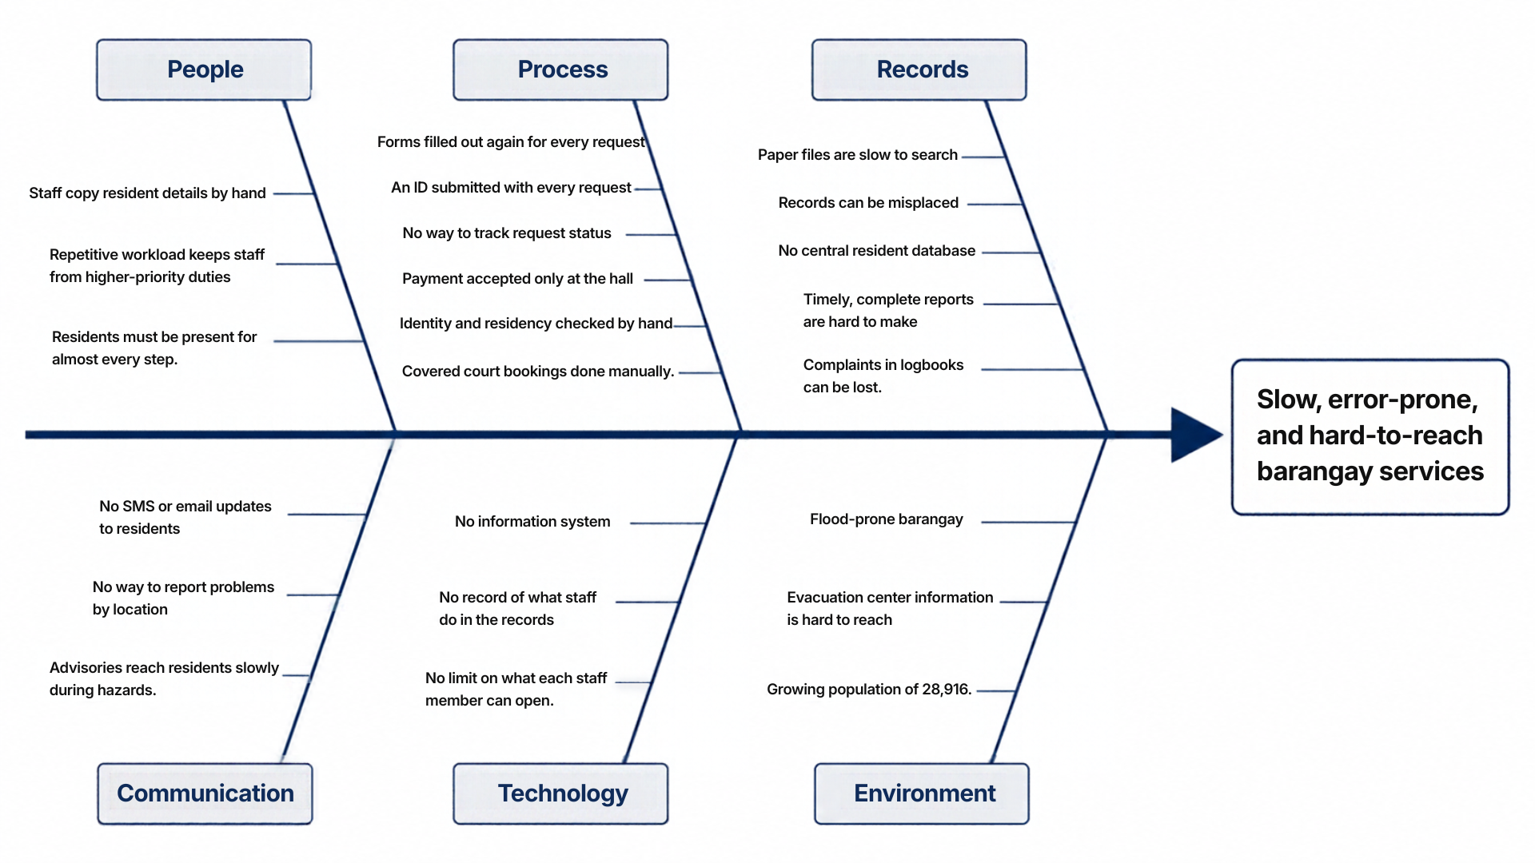

Figure 2. Fishbone diagram of the problems in the current barangay services

Each feature of PB2Link answers one or more of these causes. Verified registration and profile autofill remove the repeated forms and IDs, the Track Request page and the SMS and email notices let residents follow their requests, online payment adds an option besides paying at the hall, and the Community Issue Map gives residents a way to report problems by location. The disaster risk and preparedness tools bring advisories and evacuation information to residents, while tab access and the audit log limit and record what staff do. Since the website answers the problems raised by the barangay, it is operationally feasible.
Technical feasibility. Technical feasibility looks at whether the hardware and software needed to build and run the website are available. The website was developed and tested on laptops with at least an Intel Core i5 processor, 8 GB of RAM, and 256 GB of storage, with an internet connection. The front end was built with React 19 and Vite and styled with CSS, the back end with plain PHP, and the database with MySQL. XAMPP provided the Apache web server and MySQL during development on Windows 10 or higher, npm managed the front-end packages, Composer installed PHPMailer for sending emails, and Visual Studio Code served as the code editor. The live website runs on Linux shared hosting at pb2link.com and connects to Google Cloud Vision for ID scanning, PhilSMS for text messages, and OpenStreetMap through Leaflet for the maps. Residents and staff need only a phone or computer with a modern web browser and an internet connection. Since the researchers already owned the laptops and every development tool used is free, the website is technically feasible.
Economic feasibility. Economic feasibility compares the cost of building and running the website with its benefits. Table 1 shows the development cost from May to November 2026, and Table 2 shows the yearly cost of running the website if it is turned over to the barangay.
Table 1. Development cost of the project

Item | Description | Amount (₱)
Laptops | Already owned by the researchers | 0.00
Internet | ₱500.00 per month for seven months | 3,500.00
Transportation | ₱360.00 per round trip for three members, five visits | 1,800.00
Printing | Drafts and documents | 500.00
PhilSMS credit | About 1,428 text messages at ₱0.35 each | 500.00
Google Cloud prepayment | Credited to the account for later charges | 2,000.00
Web hosting (Hostinger) | One-year shared hosting with a free domain for one year, 20 GB storage, and weekly backups | 2,000.00
Total |  | 10,300.00

Table 2. Yearly operating cost of the website

Item | Basis | Yearly cost (₱)
Web hosting renewal | Hostinger renewal rate | ________
Domain renewal | From the second year | ________
SMS credits | 500 text messages per month × 12 months × ₱0.35 | 2,100.00
Google Cloud Vision | Up to 900 scans per month, within the 1,000 free scans | 0.00
Map, weather, and hazard sources | OpenStreetMap, Open-Meteo, RainViewer, Project NOAH, PAGASA, PHIVOLCS, GDACS, and USGS | 0.00
Total |  | 2,100.00 plus hosting and domain renewal

The development cost of ₱10,300.00 was shouldered by the researchers. If the website is turned over, the barangay would mainly pay for the web hosting, the domain, and the SMS credits, since Google Cloud Vision stays within its free monthly scans and the map, weather, and hazard sources are free to use. The number of text messages may go above 500 in a month with disasters, because advisories are counted but never blocked by the monthly limit. In return, the website is expected to reduce paperwork, repeated encoding by staff, and residents’ trips to the barangay hall, so it is economically feasible.
Schedule feasibility. Schedule feasibility checks whether the project can be finished within the available time. Table 3 shows the schedule of activities from May to November 2026, which follows the phases of RAD. The User Design and Construction phases overlap because each version of the website was designed, built, and reviewed in turn, while the writing of the paper ran alongside the development. The system testing and evaluation were done within this period.

Table 3. Gantt chart of the project activities, May to November 2026
Activity | May | Jun | Jul | Aug | Sep | Oct | Nov
Requirements Planning: interviews with the Barangay Secretary | ■ | ■
User Design and Construction, cycle 1: front-end prototype |  | ■ | ■
First prototype review |  |  | ■
User Design and Construction, cycle 2: all barangay services |  |  | ■ | ■
Second prototype review |  |  |  | ■
User Design and Construction, cycle 3: new features and security |  |  |  | ■ | ■ | ■
Third review |  |  |  |  |  | ■
Writing of Chapters 1 to 5 | ■ | ■ | ■ | ■ | ■ | ■ | ■
System testing |  |  |  |  |  | ■ | ■

Requirements Documentation
The requirements gathered were documented as functional requirements, which state what the website must do, and non-functional requirements, which state how well it must do them.
Functional requirements. The website must let residents register with a valid ID that is scanned through OCR, a verification selfie, and one-time codes for the email address and mobile number, and must let staff approve, return, or archive registrations. It must let residents request documents and custom services, book amenities, file incident reports, pay online or at the hall, and track every request, and must let staff process requests, verify payments, and print certificates and IDs. It must send notices by SMS and email, let residents pin community issues on a map limited to the barangay boundary, show weather and hazard information, evacuation centers, and street flood levels, and let staff publish advisories. It must also let staff manage waste schedules, announcements, and the About page, and let the Super Admin manage admin accounts, tab access, system settings, and the audit log.
Non-functional requirements. The website must protect resident data by storing passwords and codes only as hashes, checking each user’s session and permissions on the server, pausing sign-in after repeated incorrect passwords, and recording staff actions in an audit log. It must keep records by archiving them instead of deleting them, work on phones and computers through a web browser, and follow WCAG 2.2 Level AA on the resident side of the website. It must keep working when an outside service is unavailable, such as letting residents type their ID details when scanning is not available and sending an email when a text message fails, and it must stay within the monthly limits for ID scans and text messages. It must keep a resident’s location on the device when finding the nearest evacuation center, and it relies on the weekly backups of the web hosting for its data.

System Design
The website was designed to replace the slow manual process of the barangay with an organized digital workspace. The researchers planned a dual-side website structure, which means the website is split into two parts: an open resident side for residents and a secure admin side for barangay staff.
On the resident side, the design was kept simple, since not all residents are used to computers. The resident side uses clear buttons and plain forms so anyone can register, request a document, report a community issue on the map, or book a facility from a phone or a computer. New residents must register and pass the OCR ID scan, the selfie check, and the email and mobile number codes. Accounts that pass every check are approved automatically, while the others are reviewed by staff before they gain full access. It also follows WCAG 2.2 and includes an accessibility menu for residents with different needs.
On the admin side, the design focuses on security and order. The website connects to a central MySQL database where all resident profiles are stored. A key part of the design is the Create, Read, Update, and Archive policy. Instead of letting staff delete a record for good, the website only allows archiving, which protects community data from being lost by mistake. The admin interface sorts pending registrations and document requests so staff can review them, verify payments and O.R. numbers, set statuses, and trigger automated emails and SMS text messages to the resident. Each admin only sees the tabs they are allowed to open, and every staff action is saved in the audit log.
To present the design clearly, the researchers prepared several diagrams. The Use Case Diagram (Figure 3) shows how the Guest, Resident, Standard Admin, and Super Admin interact with the website functions. The Entity Relationship Diagram (Figure 4) shows the database entities, their links, and key attributes. The System Architecture (Figure 5) shows how users, the browser, the PHP server, the database, and the outside services connect. The Process Flow (Figure 6) shows the lifecycle of a user and an admin, from registration and verification through requests, mapping reports, and notifications.
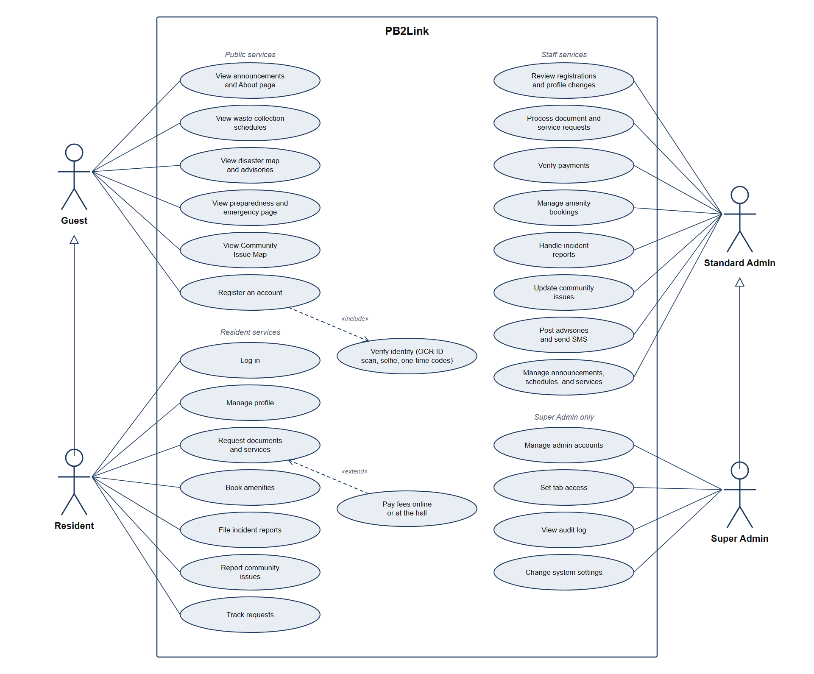
Figure 3. Use case diagram of PB2Link
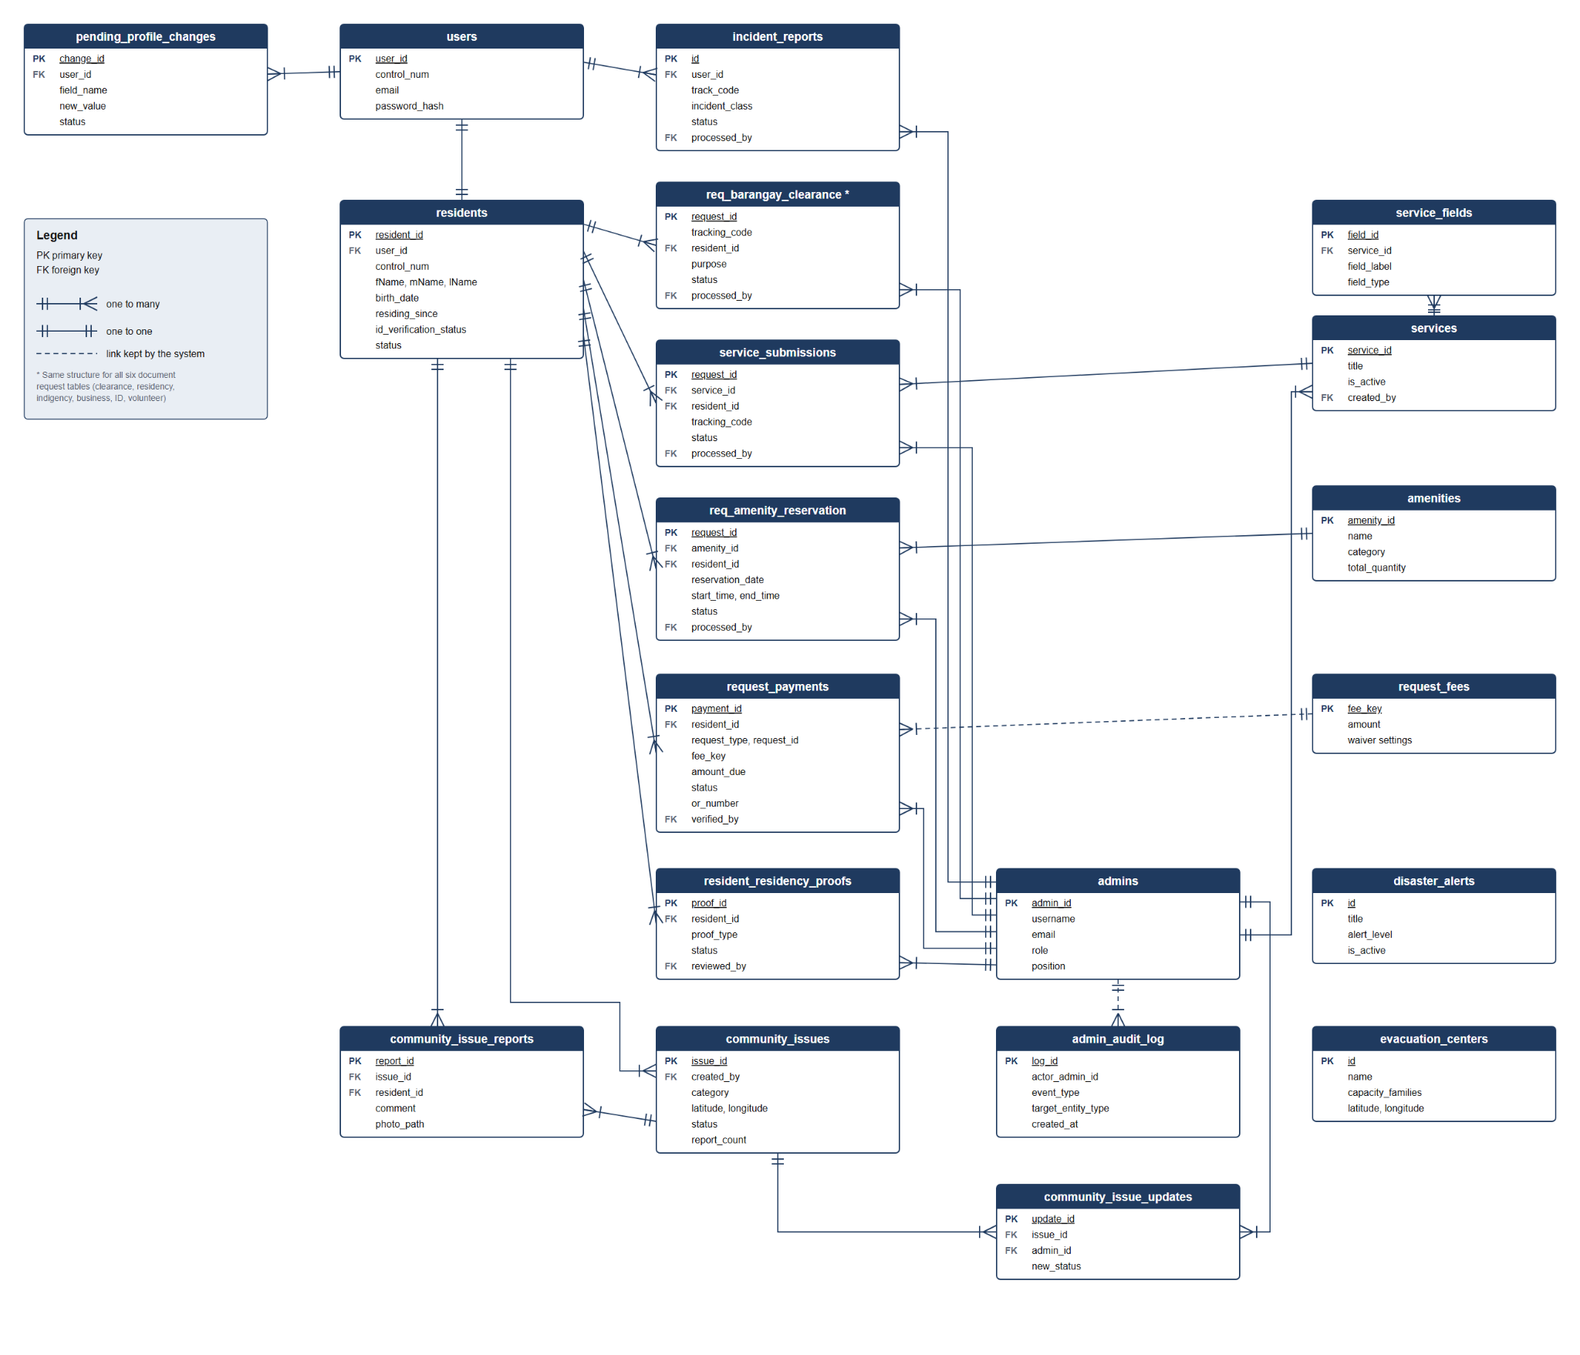
Figure 4. Entity relationship diagram of PB2Link
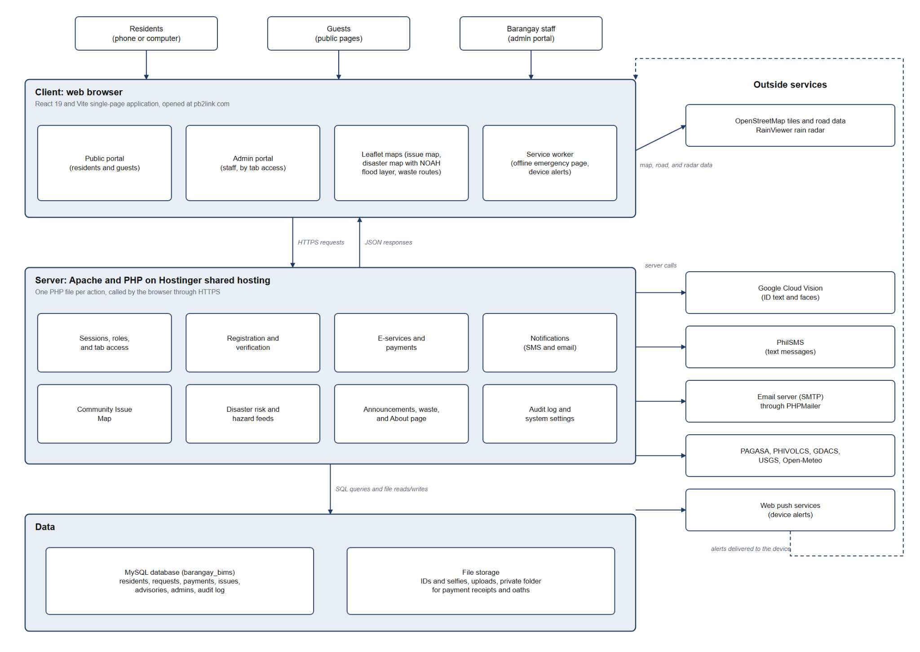
Figure 5. System architecture of PB2Link
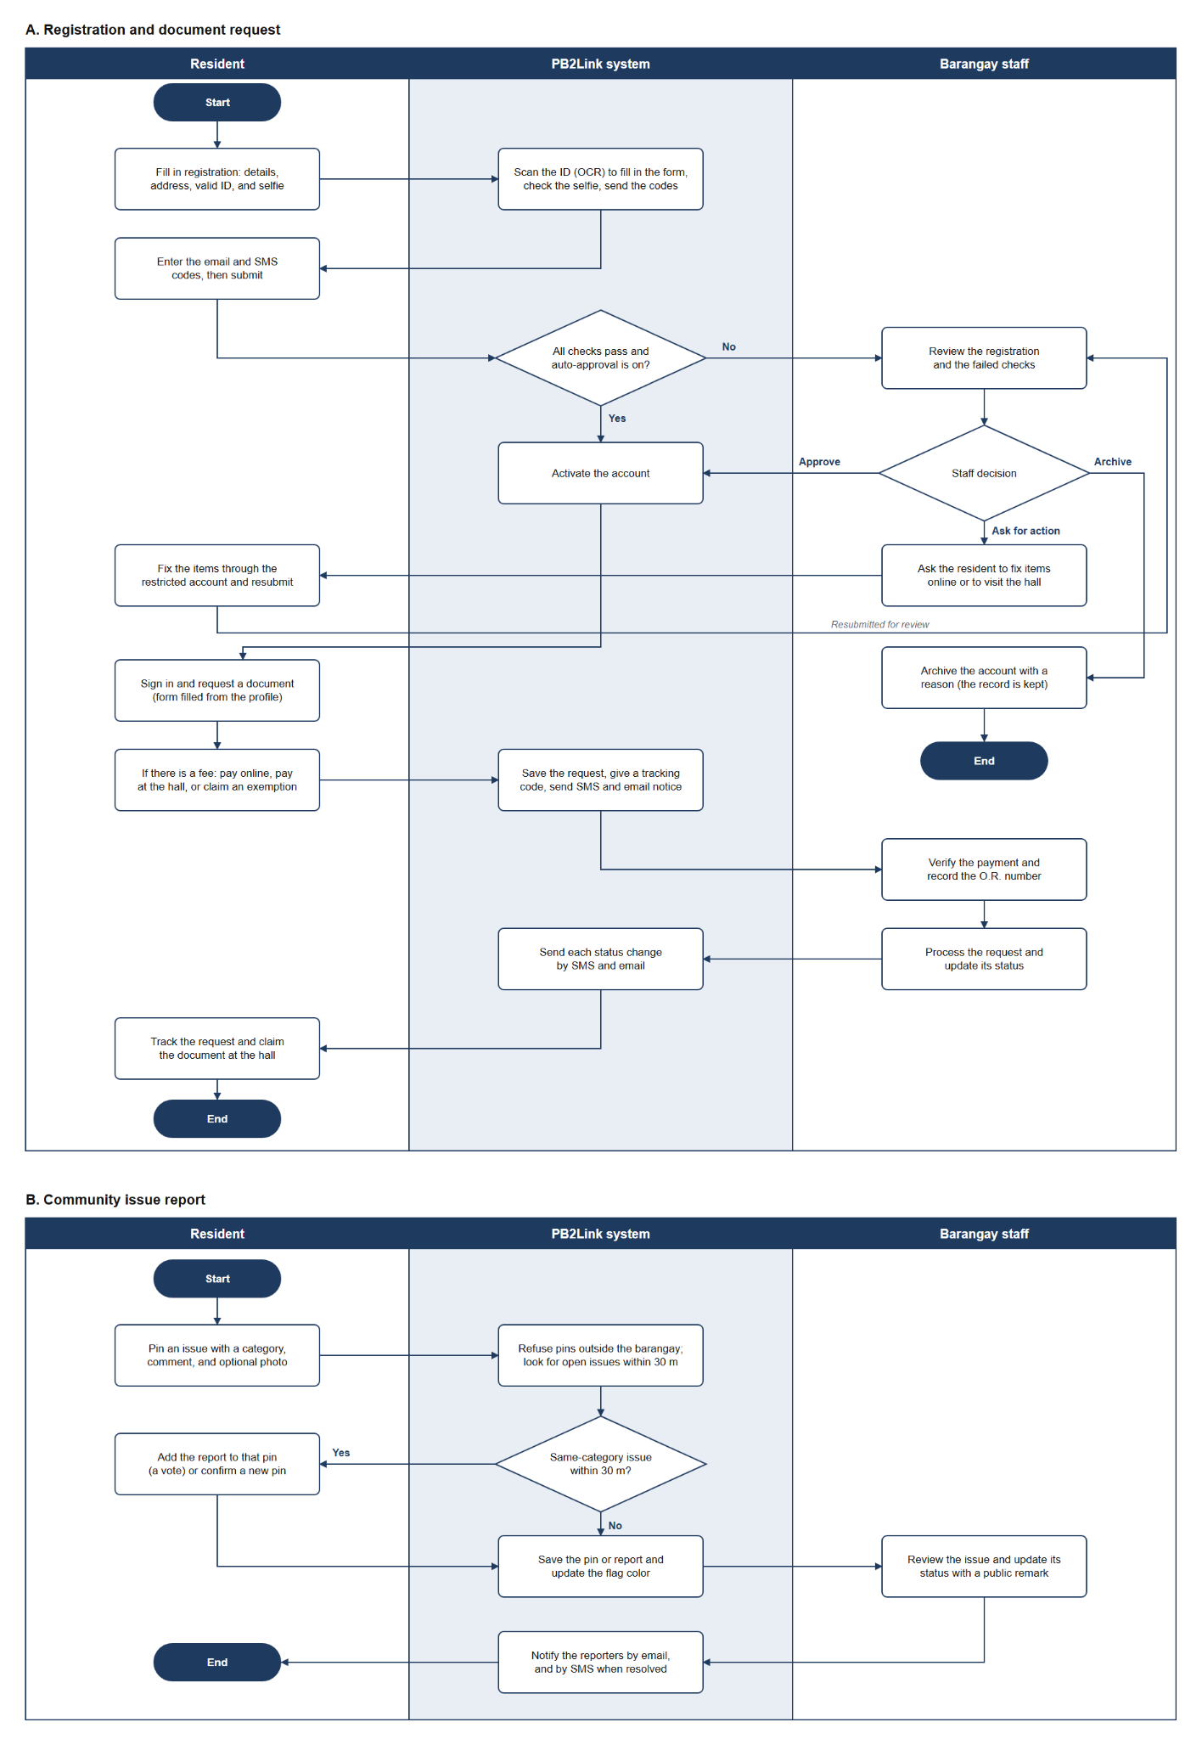
Figure 6. Process flow of PB2Link

SYSTEM DEVELOPMENT
System development covers the actual building of PB2Link during the Construction phase. The researchers wrote the front end in React 19 with Vite and the back end in plain PHP with a MySQL database, using Visual Studio Code and XAMPP on Windows, npm for the front-end packages, and Composer for PHPMailer, and kept the source code in a Git repository on GitHub. Each module was built as a set of React pages that call their own PHP files on the server.
The researchers followed secure coding practices. Database queries use prepared statements, passwords and verification codes are stored only as hashes, the server checks every admin request against the admin’s role and tab permissions, and uploaded files are stored in folders where scripts cannot run. Outside services were added through their web APIs: Google Cloud Vision for the ID scan and the selfie check, PhilSMS for text messages, PHPMailer with SMTP for emails, Leaflet with OpenStreetMap for the maps, and Open-Meteo, RainViewer, Project NOAH, PAGASA, PHIVOLCS, GDACS, and USGS for the disaster features. The website is hosted on Hostinger shared hosting at pb2link.com.

SYSTEM TESTING
The researchers tested PB2Link at four levels to make sure that it worked as intended before it was evaluated. All tests used sample data, and text messages were sent through a local test gateway so that no real resident received them.
Unit testing. Each module was tested on its own, such as registration, a document request, an amenity booking, a payment upload, and an issue report, using written test cases.
Integration testing. The researchers checked that the parts of the website worked together: that the pages saved data through the PHP server to the database, that an ID photo was read by Google Cloud Vision and filled in the form, and that a status change sent the matching SMS and email notice.
System testing. The whole website was tested against its functional and non-functional requirements using test case tables, each with a test case number, the test scenario, the expected result, the actual result, and a pass or fail remark. These followed black box testing, which checks each feature by its inputs and expected outputs without looking at the code. This included security tests, such as checking that a resident cannot open admin pages and that an admin without permission for a tab is refused, compatibility tests on common browsers on phones and computers, and accessibility checks with an automated tool and the keyboard. The test case tables are presented in Appendix 7. The resident side was also checked against WCAG 2.2 Level AA with the axe-core automated accessibility tool and by using every page with the keyboard only.
User acceptance testing. During Cutover, barangay staff and selected residents used the website with sample data to confirm that it did what they needed. The barangay staff recorded the result in a testing sheet, shown in Appendix 2. Errors found at any level of testing were fixed and tested again.

SYSTEM EVALUATION
After testing, the website was evaluated using the ISO/IEC 9126-1 software product quality model (ISO, 2001). This model rates a system on six characteristics: functionality, reliability, usability, efficiency, maintainability, and portability. A questionnaire based on these characteristics was used to measure how well the website met the needs of its users. The questionnaire, shown in Appendix 2, was adapted from ISO/IEC 9126 for PB2Link and was reviewed by the researchers’ adviser before it was given to the respondents.
Respondents. The respondents were grouped into three, as shown in Table 4. The first group was the barangay staff who use the admin side of the website. Since they were fewer than 10, all five of them were included through total enumeration. The second group was the residents, who were chosen through purposive sampling, in which respondents are selected because they have characteristics that fit the purpose of the study (Andrade, 2021). Since the evaluation measured the quality of the website, the residents had to try its resident features themselves, starting with registration, which requires a valid ID and a selfie with the ID. A resident was included only if they lived in Barangay Pasong Buaya II, were 18 years old or above, agreed to have their valid ID and personal information used for the evaluation, and registered on the website at pb2link.com. The evaluation was conducted from November 5 to 7, 2026. The researchers aimed for 100 residents, but only those who met all the criteria took part, which gave 30 residents. This number was close to the respondents of similar barangay websites in related studies, such as the 30 officials and staff in Amar (2025) and the 16 constituents in Bautista et al. (2023). Because the residents were not chosen at random, the results describe the residents who used the website and do not represent all 28,916 residents of the barangay. The third group was five IT experts chosen through purposive sampling, who held a degree in information technology or computer science and had at least two years of experience in web development or in teaching programming. The researchers’ adviser and the panel members were not included, to avoid bias. The residents and the barangay staff rated functionality, reliability, usability, and efficiency, and the IT experts rated all six characteristics.

Table 4. Distribution of respondents
Respondents | Sampling technique | Number
Barangay staff | Total enumeration | 5
Residents | Purposive sampling | 30
IT experts | Purposive sampling | 5
Total |  | 40

Data privacy. The evaluation followed Republic Act No. 10173, the Data Privacy Act of 2012. Before the evaluation, the researchers asked the barangay for permission through a letter to the barangay secretary, and each resident read, checked, and signed a consent form before registering. The form stated what would be collected, namely a photo of the valid ID, personal information such as the name, address, birth date, and contact details, and the answers to the questionnaire. The data were stored only in the website’s database, only the researchers could access them, and they were shown only to the IT instructors during the capstone presentation and defense. All of the residents’ data will be permanently deleted after the final defense. The request letter and the consent form are shown in Appendix 2.
Data analysis plan. The respondents rated each item on a five-point scale, where 5 means Excellent, 4 means Very Good, 3 means Good, 2 means Fair, and 1 means Poor. The weighted mean for each item was computed by multiplying the number of respondents who chose a rating by the value of that rating, adding the products, and dividing the sum by the total number of respondents. In symbols, it was computed as follows:
WM = Σfx / N
where WM is the weighted mean, f is the number of respondents who chose a rating, x is the value of that rating, and N is the total number of respondents.
The weighted means were interpreted using the ranges in Table 5.
Table 5. Descriptive interpretation of the mean
NUMERICAL SCALE | INTERPRETATION
4.51 – 5.00 | Excellent
3.51 – 4.50 | Very Good
2.51 – 3.50 | Good
1.51 – 2.50 | Fair
1.50 – below | Poor
The category means and the grand mean were then computed to describe the overall quality of the website. The results of the evaluation are presented and discussed in Chapter 4. Since some of the reviewed studies used a four-point scale, their results are compared with this study through their verbal interpretations rather than their numerical means.

IMPLEMENTATION PLAN
The use of PB2Link in Barangay Pasong Buaya II depends on the decision of the barangay. For this reason, the researchers proposed a plan for its possible deployment, which the barangay may follow if it decides to adopt the website. Table 6 shows the strategies, activities, persons involved, and estimated duration of each step.
Table 6. Implementation plan for the possible deployment of PB2Link
STRATEGY | ACTIVITY | PERSON INVOLVED | DURATION
Approval from the barangay | Presentation of the website and its evaluation results; written agreement on the ownership of the website and on who pays for the web hosting, domain, and SMS credits | Researchers, Punong Barangay, barangay council | 1 week
Account turnover and setup | Turnover of the hosting, domain, PhilSMS, and Google Cloud accounts; updating the system settings to use the barangay’s own accounts | Researchers, Barangay Secretary | 1 day
Admin account setup | Creation of the Super Admin and staff accounts; setting of the tabs each staff member can open | Researchers, Barangay Secretary | 1 day
Staff training | Hands-on orientation on the admin and resident sides of the website; turnover of the user manual | Researchers, barangay staff | 2 days
Data privacy and security | Registration with the National Privacy Commission and appointment of a Data Protection Officer; a security review of the website by an IT professional before full use | Punong Barangay, Data Protection Officer, IT professional | 1 month
Pilot run | Use of the website with selected residents and services; fixing of problems found | Barangay staff, selected residents, researchers | 1 month
Information distribution | Announcement of the website through the barangay’s official page, posters, and announcements on how residents can register | Barangay staff | 1 week
Full use and maintenance | Self-registration of residents, since paper records are not moved into the website; monthly database backup in addition to the weekly backups of the hosting; handling of problems and updates | Barangay staff, Barangay Secretary or a staff member assigned by the Punong Barangay | Continuous

REFERENCES
Amar, J. C. (2025). Development and evaluation of a technology-based barangay management system. International Journal of Science and Research (IJSR), 14(3), 104–107. doi:10.21275/sr25303115701
Aminmahrup, R. S., Simatupang, A. J. R., Nasution, M. F., & Kurniawan, F. (2025). Design and development of a web-based disaster incident reporting information system for BPBD Binjai. Journal of Management, Economic, and Accounting, 4(2), 557–562. doi:10.37676/jmea.v4i2.892
Andrade, C. (2021). The inconvenient truth about convenience and purposive samples. Indian Journal of Psychological Medicine, 43(1), 86–88. doi:10.1177/0253717620977000
Apiag, C. P., Cadiz, E. B., & Lincopinis, D. (2023). A review on PHP programming language [Preprint]. Retrieved from https://www.researchgate.net/publication/371166635_A_Review_on_PHP_Programming_Language
Arguelles, K. A. S., Bacala, J. L., & Montano, F. A., Jr. (2024). Web-based barangay information management system with SMS and email notifications for Barangay Malagasang 1-C, Imus City, Cavite (Unpublished undergraduate capstone project). Cavite State University – Imus Campus, Imus City, Cavite.
Arta, M. J. M., Gunadi, I. G. A., & Dantes, G. R. (2026). An integrated smart village information system for digital public services and BUMDes marketplace in Temesi Village. INOVTEK Polbeng - Seri Informatika, 11(2), 583–594. doi:10.35314/6kh1s185
Bañes, A. B. (2023). Tax management system for local government unit with SMS notification. International Journal of Multidisciplinary Research and Analysis, 6(2). doi:10.47191/ijmra/v6-i2-30
Barte, R. B., Cano, N. A. M., & Miquiabas, C. (2025). Disaster management system for Barangay Malagasang 1-G with SMS auto-response (Unpublished undergraduate capstone project). Cavite State University – Imus Campus, Imus City, Cavite.
Bautista, M. T. T., Bolonos, A. K. B., Camba, U. J., De Guzman, L. M., Goh, M. L. I., Raguro, M. C. F., & Tolentino, L. S. (2023). BALANGAY: A web-based document request and incident reporting system with decision support for barangay program development. In A. K. Nagar, D. S. Jat, D. K. Mishra, & A. Joshi (Eds.), Intelligent sustainable systems (Lecture Notes in Networks and Systems, pp. 127–136). Singapore: Springer. doi:10.1007/978-981-19-7663-6_13
Cabaobao, A. A., Jr., Malubag, S. L., Briones, J., & Abante, M. V. (2024). Evaluating workflow automation efficiency in a government agency in the Philippines. International Journal of Entrepreneurship and Sustainability Studies, 4(2), 30–46. doi:10.31098/ijeass.v4i2.2749
Dandan, D., Cruz, M. M., Soriano, A., & Balogo, K. (2026). Evaluating the effectiveness of barangay management system for local governance using software quality model of ISO 25010:2011. International Journal of Interdisciplinary Viewpoints, 2(3), 30–35. doi:10.64612/ijiv.v2i3.72
Data Privacy Act of 2012, Rep. Act No. 10173 (2012). Retrieved from https://lawphil.net/statutes/repacts/ra2012/ra_10173_2012.html
Del Pilar, C. G. E., Nale, S. G. R., Jinio, A. L., Abando, D. S., Blanco, M. C. R., & Sison, A. A. R. C. (2024). B-GIS: Modernizing local governance through a web-based barangay geographic information system for Barangay 99, Tondo, Manila. In 2024 International Conference on Intelligent Cybernetics Technology & Applications (ICICyTA) (pp. 161–166). Piscataway, NJ: IEEE. doi:10.1109/ICICyTA64807.2024.10912845
Dela Cerna, M. A. (2023). Development and implementation of an office automation system for barangay local government units. In 2023 4th International Conference for Emerging Technology (INCET) (pp. 1–9). Piscataway, NJ: IEEE. doi:10.1109/INCET57972.2023.10170650
Department of Information and Communications Technology. (2019). E-government masterplan 2022. Retrieved from https://dict.gov.ph/ictstatistics/wp-content/uploads/2020/03/EGMP-2022.pdf
Department of the Interior and Local Government Region IV-A. (27 December 2025). DILG pushes full digital shift in barangays through nationwide LGUSS-BIMS adoption. Retrieved from https://calabarzon.dilg.gov.ph/dilg-pushes-full-digital-shift-in-barangays-through-nationwide-lguss-bims-adoption/
Ease of Doing Business and Efficient Government Service Delivery Act of 2018, Rep. Act No. 11032 (2018). Retrieved from https://lawphil.net/statutes/repacts/ra2018/ra_11032_2018.html
E-Governance Act, Rep. Act No. 12254 (2025). Retrieved from https://lawphil.net/statutes/repacts/ra2025/ra_12254_2025.html
Exec. Order No. 170, s. 2022, Adoption of digital payments for government disbursements and collections (2022). Retrieved from https://lawphil.net/executive/execord/eo2022/eo_170_2022.html
First Time Jobseekers Assistance Act, Rep. Act No. 11261 (2019). Retrieved from https://lawphil.net/statutes/repacts/ra2019/ra_11261_2019.html
G. C., S. B., Gurung, S. K., Rana, S. B. J. B., & Dhungana, B. R. (2024). E-governance, citizen satisfaction and net benefits: The moderating effect of digital divide. Cogent Business & Management, 11(1), 2402512. doi:10.1080/23311975.2024.2402512
Holila, H., Pratama, A. R., Lestari, S. A. P., & Indra, J. (2024). Introduction national identification number and name on ID card using OCR (optical character recognition) method. Jurnal Teknik Informatika (Jutif), 5(4), 1191–1196. doi:10.52436/1.jutif.2024.5.4.2242
Hosseini, F. S., Jelokhani-Niaraki, M., & Faraji Sabokbar, H. (2024). A public participation GIS for infrastructure assessment in rural human settlements. Applied Spatial Analysis and Policy, 17(4), 1521–1544. doi:10.1007/s12061-024-09594-7
Ikram, R. A. D., Kahar, A. M., & Gusrizal. (2025). Development of village administrative data management system through PAPEDA (Village Population Administration Development Application) in Pitu Village, North Halmahera Regency. Proceedings of the International Conference on Data Science and Official Statistics, 2025(1). doi:10.34123/icdsos.v2025i1.504
International Organization for Standardization. (2001). Software engineering — Product quality — Part 1: Quality model (ISO/IEC Standard No. 9126-1:2001). Retrieved from https://www.iso.org/standard/22749.html
International Organization for Standardization. (2018). Quality management — Customer satisfaction — Guidelines for complaints handling in organizations (ISO Standard No. 10002:2018). Retrieved from https://www.iso.org/standard/71580.html
Jamis, M. N., Coloma, C. R., Cabanlit, P. J. Q., Balanay, R. V., Menor, S. R. N., Yabut, E. R., & Caluya, S. S. (2022). One Barangay: A mobile and web barangay management system. In 2022 2nd International Conference in Information and Computing Research (iCORE) (pp. 202–207). Piscataway, NJ: IEEE. doi:10.1109/iCORE58172.2022.00055
Komperla, V., Pratiba, D., Ghuli, P., & Pattar, R. (2022). React: A detailed survey. Indonesian Journal of Electrical Engineering and Computer Science, 26(3), 1710–1717. doi:10.11591/ijeecs.v26.i3.pp1710-1717
Libadia, M., Botangen, K. A., Lucero, P. J., & Tecson, J. (2025). Development of a web-based records management system: An ERMS initiative for the Office of Senior Citizen Affairs in the Philippines. Records Management Journal, 35(2), 160–179. doi:10.1108/RMJ-06-2023-0031
Local Government Code of 1991, Rep. Act No. 7160 (1991). Retrieved from https://lawphil.net/statutes/repacts/ra1991/ra_7160_1991.html
Manun-og, M., Manun-og, M., Wales, A. R., Balili, D., & Togonon, J. (2022). Development of a records management system with GIS integration: Enabling tool for disaster risk management. SciEnggJ, 15(2), 72–78. doi:10.54645/2022152LPS-32
Melendres, U. M., & Aranda, K. M. (2024). Development and evaluation of a web-based resident information management system. Journal of Computer, Software, and Program, 1(1), 14–22. doi:10.69739/jcsp.v1i1.50
Mitre, X., & Baci, N. (2025). Assessing the web accessibility compliance of municipality websites in Albania with WCAG 2.2 standards. Journal of Natural Sciences, 37, 102–120. doi:10.70827/atwacom
National Archives of the Philippines Act of 2007, Rep. Act No. 9470 (2007). Retrieved from https://lawphil.net/statutes/repacts/ra2007/ra_9470_2007.html
OpenGov Asia. (3 May 2025). The Philippines: Apps to advance digital transformation. Retrieved from https://archive.opengovasia.com/2025/05/03/the-philippines-apps-to-advance-digital-transformation/
Pahuriray, A. V., & Cerna, P. D. (2025). FRiMap: Development of web-GIS flood risk index mapping platform for disaster risk reduction. International Journal on Advanced Science, Engineering and Information Technology, 15(3), 878–886. doi:10.18517/ijaseit.15.3.20136
Philippine Disaster Risk Reduction and Management Act of 2010, Rep. Act No. 10121 (2010). Retrieved from https://lawphil.net/statutes/repacts/ra2010/ra_10121_2010.html
Philippine Identification System Act, Rep. Act No. 11055 (2018). Retrieved from https://lawphil.net/statutes/repacts/ra2018/ra_11055_2018.html
Philippine Statistics Authority. (2025). 2024 Census of Population (POPCEN) population counts declared official by the President. Retrieved from https://psa.gov.ph/content/2024-census-population-popcen-population-counts-declared-official-president
Presidential Communications Office. (5 June 2025a). eGov app streamlines gov’t services. People’s Journal. Retrieved from https://journalnews.com.ph/?p=303018
Presidential Communications Office. (25 June 2025b). Win for PH. People’s Journal. Retrieved from https://journalnews.com.ph/?p=307150
Presidential Communications Office. (26 November 2025c). DPWH Transparency Portal vs graft launched. People’s Journal. Retrieved from https://journalnews.com.ph/?p=337684
Puji Lestari, N. (2023). Innovation of digital-based licensing services in the One-Stop Integrated Service of West Sulawesi Province. KnE Social Sciences, 8(17). doi:10.18502/kss.v8i17.14152
Romero, E. R. (2021). Standardization of records management system in local government units (Phase 1: Assessment of the records management system of local government units). International Journal of Research Publications, 87(1). doi:10.47119/IJRP1008711020212366
Saflor, C. S. R., & Kudhal, K. (2026). Emergency alert and warning systems and their impact on sustainable disaster preparedness and awareness in the Philippines: A SEM–ANN analysis. Sustainability, 18(7), 3590. doi:10.3390/su18073590
Sahu, S. K. (2024). Building secure PHP applications: A comprehensive guide to protecting your web applications from threats. Berkeley, CA: Apress. doi:10.1007/979-8-8688-0932-3
Siman, K. F., & Wiratama, J. (2023). A web-based village administrative information systems fo improvement quality of service towards smart village concept. G-Tech: Jurnal Teknologi Terapan, 7(4), 1519–1528. doi:10.33379/gtech.v7i4.3196
Singgalen, Y. A. (2024). Implementation of rapid application development (RAD) for community-based ecotourism monitoring system. Journal of Information System Research (JOSH), 5(2), 520–530. doi:10.47065/josh.v5i2.4749
Taliep, N., & Ismail, G. (2023). Community mapping method. In P. Liamputtong (Ed.), Handbook of social sciences and global public health (pp. 1–22). Cham, Switzerland: Springer. doi:10.1007/978-3-030-96778-9_57-2
Taruc, F. S., Martin, T. A. S., Olipas, C. N. P., & Alegado, R. T. (2023). Docu-Go: The development and assessment of a web-based barangay document requesting system. International Journal of Information Technology and Computer Engineering, 3(4), 40–49. doi:10.55529/ijitc.34.40.49
Thammarak, K., Kongkla, P., Sirisathitkul, Y., & Intakosum, S. (2022). Comparative analysis of Tesseract and Google Cloud Vision for Thai vehicle registration certificate. International Journal of Electrical and Computer Engineering, 12(2), 1849–1858. doi:10.11591/ijece.v12i2.pp1849-1858
Tosper, R., Mangalino, J., Obena, K., Simon, M., Tayag, M., Villano, K. J., & Reyes, D. (2025). WebYu: A Barangay Yuson web-based information management system initiatives. Psychology and Education: A Multidisciplinary Journal, 37(5), 432–442. doi:10.70838/pemj.370502
Yıldırım, S., & Bostancı, S. H. (2021). The efficiency of e-government portal management from a citizen perspective: Evidences from Turkey. World Journal of Science, Technology and Sustainable Development, 18(3), 259–273. doi:10.1108/WJSTSD-04-2021-0049

APPENDICES
Appendix 1. Relevant source code

Appendix 2. Evaluation tool or test documents
Evaluation Questionnaire
Consent statement
Good day! We are Bachelor of Science in Information Technology students of Cavite State University, Imus Campus, conducting our capstone project, PB2Link, a website for Barangay Pasong Buaya II. This questionnaire asks you to rate the quality of the website. Taking part is voluntary, and you may stop at any time. Your answers will be used only for this study, will be reported only as group results, and will be handled in line with the Data Privacy Act of 2012 (Republic Act No. 10173). We do not ask for your name. If you have questions, you may contact the researchers at ____________________.
☐ I have read the statement above and agree to take part in this evaluation.
Respondent information
Respondent group: ☐ Resident of Barangay Pasong Buaya II ☐ Barangay staff ☐ IT expert
For residents: ☐ I am 18 years old or above. ☐ I have used the resident features of PB2Link.
For IT experts: Degree: ____________________ Years of experience in web development or in teaching programming: ______
Instructions
Rate each statement by checking the number that best describes PB2Link: 5 = Excellent, 4 = Very Good, 3 = Good, 2 = Fair, 1 = Poor. Parts I to IV are answered by all respondents, and Parts V and VI by IT experts only.
Appendix Table 1. Functionality (Part I, all respondents)

Indicator | 5 | 4 | 3 | 2 | 1
1. The website has the functions needed for the barangay’s services, such as registration, document requests, payments, reports, and notices.
2. Residents receive SMS or email updates when the status of their request changes.
3. The website gives correct results, such as correct form details, statuses, and fees.
4. The ID scanner correctly fills in the registration form from the photo of the ID.
5. The maps correctly show evacuation centers, flood-prone areas, and community issues within the barangay.
6. The website works correctly with the services it uses, such as SMS, email, ID scanning, and maps.
7. Only authorized users can see personal data and records.
8. The website checks the identity of users before giving them access.
9. The website follows the barangay’s requirements and rules for each service.

Appendix Table 2. Reliability (Part II, all respondents)

Indicator | 5 | 4 | 3 | 2 | 1
1. The website works without errors during normal use.
2. The website keeps working, or says what to do next, when a service such as SMS or ID scanning is not available.
3. Data is kept and work can continue after an error or interruption.

Appendix Table 3. Usability (Part III, all respondents)

Indicator | 5 | 4 | 3 | 2 | 1
1. I can easily tell what each part of the website is for.
2. The website is easy to learn, even for first-time users.
3. The website is easy to operate and control.
4. People with different needs can use the website, such as those who need larger text or use only a keyboard.
5. The screens are clear and pleasant to look at.

Appendix Table 4. Efficiency (Part IV, all respondents)

Indicator | 5 | 4 | 3 | 2 | 1
1. Pages and forms load and respond quickly.
2. The website runs smoothly on my device without slowing it down.
3. The website still works well when many people use it at the same time.

Appendix Table 5. Maintainability (Part V, IT experts only)

Indicator | 5 | 4 | 3 | 2 | 1
1. Errors and their causes can be found easily.
2. The website can be changed or improved easily.
3. A change in one part of the website does not cause errors in other parts.
4. The website’s functions can be tested easily.

Appendix Table 6. Portability (Part VI, IT experts only)

Indicator | 5 | 4 | 3 | 2 | 1
1. The website adapts to different devices, screen sizes, and browsers.
2. The website can be deployed on a web host easily.
3. The website works properly alongside other software on the same device or server.
4. The website can replace the barangay’s manual process for the same tasks.

Comments and suggestions: ________________________________________________
User Acceptance Testing Sheet
This sheet records the result of the user acceptance testing of PB2Link. During the Cutover phase, the barangay staff used the website with sample data and checked whether each module does what the barangay needs. For each module, the staff mark Accepted or Not Accepted and write down any problem they found. A module marked Not Accepted is fixed and tested again.
Date of testing: ____________________
Place of testing: Barangay Hall of Pasong Buaya II, Imus, Cavite
Data used: Sample data only
Appendix Table 7. User acceptance testing results

Module | What the staff checked | Accepted | Not Accepted | Remarks
Registration and verification | A resident can register with a scanned ID, a selfie, and email and mobile codes, and staff can approve, return, or archive the account. | ☐ | ☐
Sign-in and profile | Residents and staff can sign in, and residents can update their profile with the needed codes and proofs. | ☐ | ☐
Document and service requests and payments | Residents can request documents and services and pay online or at the hall, and staff can process requests, verify payments, and print certificates and IDs. | ☐ | ☐
Amenity booking and incident reports | Residents can book facilities and file incident reports, and staff can approve bookings and update reports. | ☐ | ☐
Community Issue Map | Residents can pin issues inside the barangay, and staff can update, merge, and close them. | ☐ | ☐
Disaster risk and notifications | Staff can publish advisories and manage evacuation centers, and residents receive notices by SMS and email. | ☐ | ☐
Administration and security | Each admin sees only the tabs they are allowed to open, and staff actions are saved in the audit log. | ☐ | ☐
Compatibility and accessibility | The website works on phones and computers and can be used with the accessibility menu. | ☐ | ☐

Certification
We, the undersigned barangay staff, have tested PB2Link using sample data and confirm that the results above are true.
Appendix Table 8. Barangay staff who took part in the testing

Name | Position | Signature | Date

Request Letter and Consent Form for the Evaluation
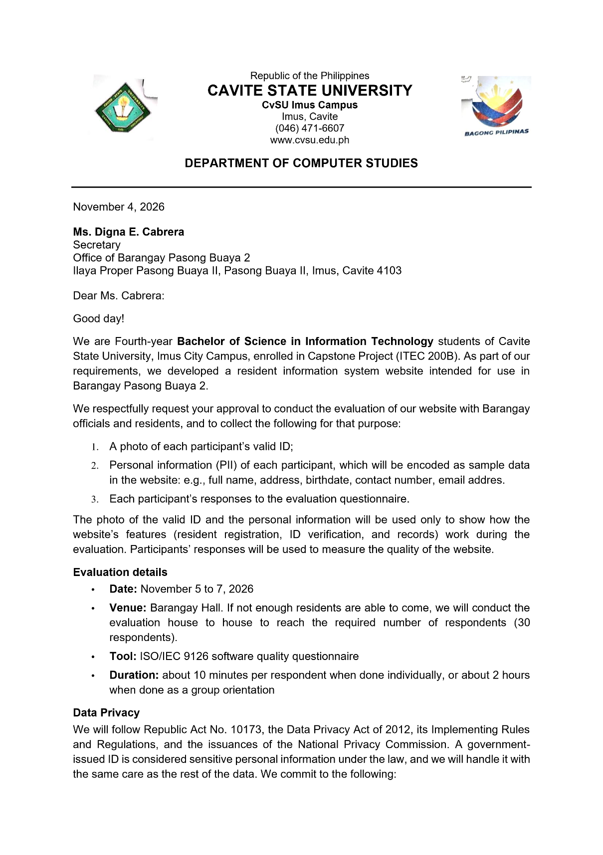
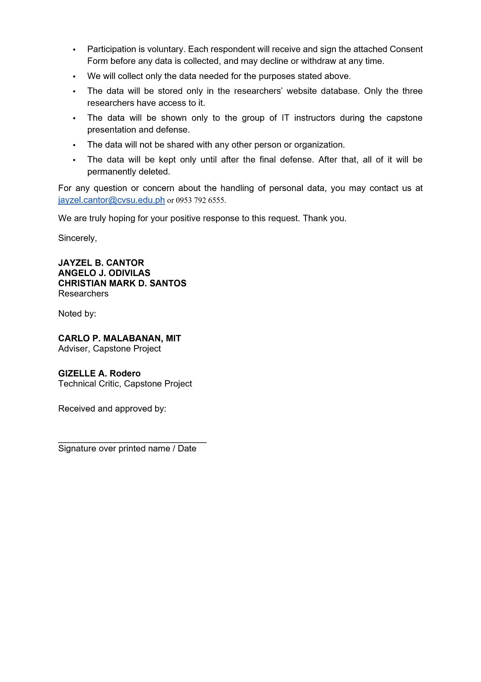
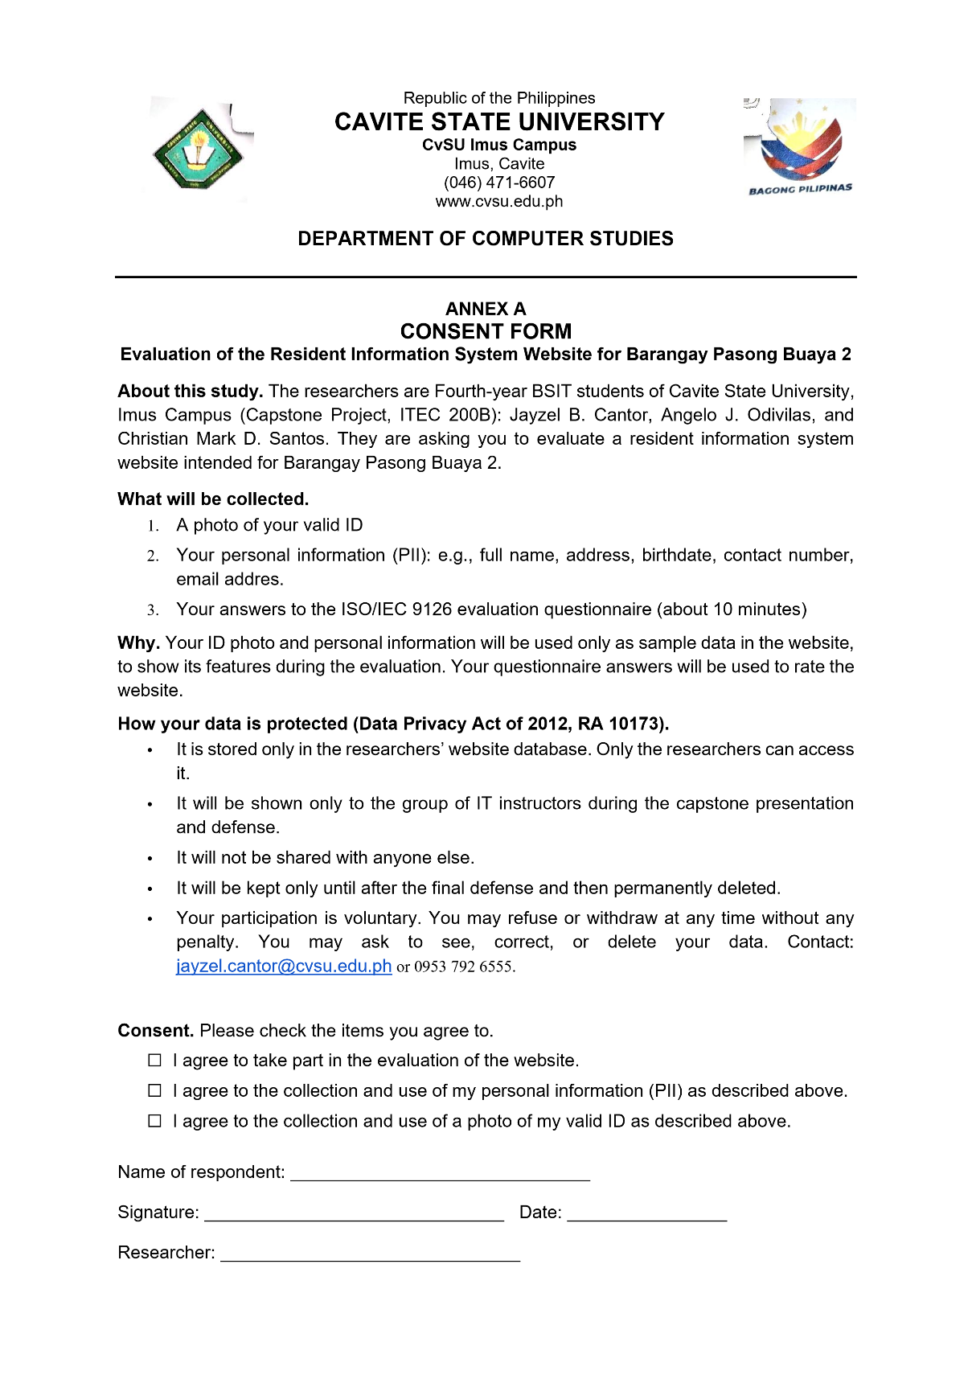
Appendix 3. Sample input/output/reports

Appendix 4. User’s guide

Appendix 5. Process/data/information flow

Appendix 6. Screen layouts

Appendix 7. Test results
Test Case Tables
Appendix Table 9. Registration and verification test cases
Test Case No. | Test Scenario | Expected Result | Actual Result | Remarks (Pass/Fail)
TC-01 | Register and upload a clear photo of a valid ID | The ID scan fills in the name, birth date, and ID number, and the resident can edit them
TC-02 | Upload a blurry ID photo, or register while ID scanning is unavailable | A message asks the resident to type the details, and registration can continue
TC-03 | Upload the ID front again as the selfie | The selfie is flagged right away and a retake is asked for
TC-04 | Upload a selfie that does not show the ID | A retake is asked for; after two failed tries the resident may continue and the account goes to staff review
TC-05 | Enter a wrong email code five times | The code is locked and a new code must be requested
TC-06 | Change the mobile number after receiving the SMS code, then submit | Registration is refused because the number did not receive the code
TC-07 | Register as an adult whose ID shows a Pasong Buaya II address, with all checks passing and auto-approval on | The account becomes Active right away
TC-08 | Enter a move-in month less than six months ago without a proof | Registration is refused and an HOA endorsement or certification is asked for
TC-09 | Register an applicant under 18 without a guardian’s ID | Registration is refused and the guardian’s documents are asked for
TC-10 | Register with the same name and birth date as an existing resident | The account stays Pending with a possible duplicate in its review reasons

Appendix Table 10. Sign-in and profile test cases
Test Case No. | Test Scenario | Expected Result | Actual Result | Remarks (Pass/Fail)
TC-11 | Sign in with a correct email and password on an Active account | The resident’s pages open
TC-12 | Sign in with a wrong password, then with an unregistered email | The same error message shows for both
TC-13 | Sign in to a Pending account | A message says the account is still under review, and no pages open
TC-14 | Sign in to an account where staff asked the resident to fix items online | Only Edit Profile opens, with the list of items to fix
TC-15 | Change the email address in Edit Profile | A code goes to the new email, and the change applies only after the code is entered
TC-16 | Change the home address in Edit Profile | A code and a proof of address are required, and the old address stays until staff approve
TC-17 | Enter a wrong password five times for the same email | Warnings show the tries left, and after the fifth, sign-in for that email is paused for 15 minutes
TC-18 | Enter a wrong password five times on an admin account | Sign-in is paused, the event is recorded in the audit log, and the admin receives an email
TC-19 | Use Forgot password while sign-in is paused | A reset code is sent and the password can be changed

Appendix Table 11. Document and service request and payment test cases
Test Case No. | Test Scenario | Expected Result | Actual Result | Remarks (Pass/Fail)
TC-20 | Request a Barangay Clearance for oneself | The form is filled from the profile, the registration ID is attached, a tracking code shows, and an SMS and email notice are sent
TC-21 | Request a document for another person without their ID or an authorization letter | The request is refused, naming the missing file
TC-22 | Open a service that staff have closed | A notice shows that the service is closed, and the form cannot be sent
TC-23 | Pay online by entering the reference number and uploading the receipt | The payment status shows For Verification
TC-24 | Use the same receipt or reference number on a second request | It is refused as already used
TC-25 | Staff set a request to Ready for Pick Up before verifying its online payment | The change is refused
TC-26 | Staff verify a payment and enter the O.R. number | The payment shows Paid, and the resident is notified
TC-27 | A resident with verified senior citizen, PWD, or indigent status requests a document | The fee is waived
TC-28 | A resident living in the barangay under six months requests a Clearance with a Pending proof | The request is accepted but cannot be marked ready until staff verify the proof
TC-29 | Submit a custom service form with a required question left blank | The form is refused, naming the question
TC-30 | Open Track Request after a custom service request is rejected | Each request shows its status and payment, and the rejected request shows Send Again

Appendix Table 12. Amenity booking and incident report test cases
Test Case No. | Test Scenario | Expected Result | Actual Result | Remarks (Pass/Fail)
TC-31 | Book a venue at a time that overlaps an approved booking | The booking is refused
TC-32 | Book more equipment than is still available that day | The booking is refused
TC-33 | Make a third active booking | It is refused, since the limit is two active bookings
TC-34 | Open the ambulance | Its hotline number shows instead of a booking form
TC-35 | Cancel one’s own Pending booking from Track Request | The booking becomes Cancelled
TC-36 | File an incident report with a photo | It is saved with a tracking code, and the resident is notified by their chosen channel

Appendix Table 13. Community Issue Map test cases
Test Case No. | Test Scenario | Expected Result | Actual Result | Remarks (Pass/Fail)
TC-37 | Drop a pin outside the barangay boundary | The pin is refused
TC-38 | Drop a pin within 30 m of an open issue of the same category | The resident is asked to add the report to that pin or confirm a new pin
TC-39 | Report the same pin twice with the same account | The second report is refused
TC-40 | Create a sixth new pin in one day | It is refused, since the limit is five per day
TC-41 | Staff change an issue’s status without a remark, then with a remark | Without a remark it is refused; with a remark the public timeline updates and reporters are emailed
TC-42 | Open the issue map without signing in | Flags, counts, and statuses show, but no reporter names
TC-43 | Staff merge a duplicate pin into another open issue | The duplicate leaves the map, its reports move to the other issue, and its reporters are emailed
TC-44 | Staff switch the map to the heatmap view | Areas with more reports show hotter colors

Appendix Table 14. Disaster risk and notification test cases
Test Case No. | Test Scenario | Expected Result | Actual Result | Remarks (Pass/Fail)
TC-45 | Open the Disaster Risk page | The weather forecast and live hazard cards load; if a source fails, its card says it could not be read
TC-46 | Use "Find my nearest evacuation center" with location allowed | The nearest open center shows with its distance and a walking-directions link
TC-47 | Publish an advisory from a template with a blank such as {AREAS} still unfilled | Publishing is refused
TC-48 | Publish an advisory with automatic SMS on, then edit its wording | The SMS is sent once, and the edit does not send it again
TC-49 | Create a practice advisory | Only staff see it, and it does not appear on the public pages
TC-50 | Send a notice to a resident whose text message fails (using a mock SMS gateway) | An email is sent instead
TC-51 | Visit the site, turn off the internet, and open /emergency | The emergency page opens with the saved advisory, hotlines, and centers
TC-52 | Find the nearest evacuation center from a spot in a NOAH flood area | The result includes a note on the flood hazard level at that spot
TC-53 | Find the nearest evacuation center when every mapped center is Full or Closed | A message asks the resident to call the barangay hotline
TC-54 | Deny location access, then tap a spot on the map | The nearest center is found from the tapped spot
TC-55 | Look up a street on the Preparedness page | The street’s flood level shows, or “not mapped yet” for a street without a mapped shape

Appendix Table 15. Administration and security test cases
Test Case No. | Test Scenario | Expected Result | Actual Result | Remarks (Pass/Fail)
TC-56 | Open an admin page while signed in only as a resident | The admin login page opens
TC-57 | A standard admin without the Documents permission opens Documents | "You don’t have access to this page" shows, and the server refuses the data
TC-58 | A standard admin opens the Audit Log | Access is refused, since it is for the Super Admin only
TC-59 | A Super Admin tries to delete their own account or demote the last Super Admin | Both are refused
TC-60 | Staff archive a resident without a reason, then with a reason | Without a reason it is refused; with one the account becomes Archived, the resident is signed out, and it is recorded in the audit log
TC-61 | Staff try to edit a resident’s name directly | The edit is refused, and staff are directed to send a change request
TC-62 | Export the resident list as a standard admin, then as a Super Admin | The standard admin is refused; the Super Admin gets the file, and the export is logged
TC-63 | Type SQL code into the login and search fields | It is treated as plain text, with no error and no data shown
TC-64 | Upload a PHP file renamed as an ID image | The file is rejected

Appendix Table 16. Compatibility and accessibility test cases
Test Case No. | Test Scenario | Expected Result | Actual Result | Remarks (Pass/Fail)
TC-65 | Open the website in Chrome on an Android phone, Safari on an iPhone, and Chrome on a Windows computer | The pages display and work in all three
TC-66 | Go through the public pages using only the keyboard | Every control can be reached, and the focus outline is visible
TC-67 | Set the text size to "Larger" in the accessibility menu and reload | The text gets bigger and stays that way after the reload
TC-68 | Run an automated accessibility scan on the public pages | No critical issues are reported
TC-69 | View the public pages at 320 pixels wide | Nothing needs scrolling sideways
Appendix 8. Sample generated outputs

Appendix 9. Photo documentation

Appendix 10. Curriculum vitae

Appendix 11. Request for title defense

Appendix 12. Title approval sheet

Appendix 13. Request for adviser and technical critic

Appendix 14. Program of work (Gantt chart)

Appendix 15. Budgetary requirements

Appendix 16. Request for proposal defense

Appendix 17. Proposal defense evaluation

Appendix 18. Outline approval sheet

Appendix 19. Routing slip before ERB

Appendix 20. Certificate of approval (Ethics Review Board)

Appendix 21. Request for final defense

Appendix 22. Final defense evaluation

Appendix 23. Certificate of completion

Appendix 24. Routing slip

Appendix 25. Certification from the English critic

